Information on the production and export potential of the winemaking
and alcohol industry of Uzbekistan and the
Joint Stock Company Uzsharobsanoat JSC (UzWineIndustry)

Wine and spirits industry of Uzbekistan today
Today Uzbekistan is the main producer of grapes and products of its processing in Central Asia. Favorable climatic conditions for this industry allow us to grow many varieties here to obtain high-quality varieties of sultry, raisin, table varieties, which are possible for winter storage and transportability, for shipment for long distances, and also serve as raw materials for the production of different types of wines, juices, concentrates, cognac and champagne.
Since 2018 a new period of development of the wine industry of Uzbekistan has begun. Decree of the President of the Republic of Uzbekistan No. PP-3573 from 28.02.2018. "On measures for the fundamental improvement of the wine industry and alcohol products sale", as well as for the further sustainable development of the wine industry, attracting innovative technologies, increasing the export potential, developing wine tourism.

About the company JSC "Uzsharobsanoat"
Uzsharobsanoat was founded in the form of a joint-stock company in 2006 and for today is a state-authorized company to promote a unified industry strategy. The company includes about 200 enterprises and organizations, among which 69 are industrial enterprises, 22 bottling enterprises, 16 primary winemaking plants, 4 enterprises for the production of spirit, 2 enterprises for the production and decoration of glass, 22 bottling enterprises, 2 enterprises for the production of corking materials, and 79 wholesale bases for the sale of wine and alcoholic products in the domestic market.
The basic assortment of products of the company includes production of: rectified alcohol, vodka, alcoholic beverages, balsams, grape wines, champagne and sparkling wines, cognacs as well as cognac distillates.

Activities
Viticulture.
Now in Uzbekistan, more than 43 varieties of grapes are grown, which occupy more 98 thousand hectares, including 24,6 thousand hectares of wine European varieties, providing the needs of the wine-making enterprises of the industry. To date, the company's enterprises have more than 4,0 thousand hectares own vineyards of industrial varieties, which contribute to the strengthening of high-quality raw materials.
In recent years, the area of vineyards in all categories of farms has increased by more than 7.0 thousand hectares, production by 136 thousand tons, which in 2016 amounted to more than 1.7 million tons. In 2017-2021 it is planned to increase the level of grape production to 2.3 million tons.

Winemaking and cognac production.
To date, the company's enterprises have the opportunity for annual processing of more than 200 thousand tons of grapes. The main regions of the country for the wine and cognac industry are Samarkand, Tashkent, Bukhara, Kashkadarya and Surkhandarya regions.
The main wine grape varieties grown in Uzbekistan are Kuldzhinsky, Muscat Hungarian, Muscat Pink, Aleatico, Riesling, Rkatsiteli, Saperavi, Vassarga Black, May Black, Hindogni, Morastel, Cabernet Sauvignon, Tavkveri, Aligote, Bayan shirei, Soyaki, Parkent Pink, Bakhtieri, and Tarnau.
In the development of enterprises, large funds were invested, complete modernization and replacement of obsolete plants were carried out, distilleries of European manufacturers were introduced at 13 enterprises of the company. As a result, during the period from 2009 to 2016, the capacity for distilling cognac spirits and the production of cognac products increased from 259.3 to 424.9 thousand decaliters.

Alcohol industry and production of alcoholic beverages.
In order to supply the alcohol industry of Uzbekistan with high-quality ethyl alcohol of own production, the company includes 4 enterprises. These enterprises have the most modern equipment produced in Germany and Italy, based on the use of resource-saving technologies, which provides a large capacity for the production of ethyl spirit, as well as the possibility of producing high-quality alcohol brand "Extra", "Lux" and "Alpha".
In addition, 36 enterprises produce liquor and vodka products in the amount of 19.3 million decalitres per year.
Thanks to qualitative alcohol, produced exclusively from wheat, as well as modern technological equipment, produced vodka products firmly won not only the domestic market.
In particular, premium vodka Royal Elite produced by the oldest enterprise of Uzbekistan - JSC "Combine Tashkentvino", which celebrated its 150th anniversary in 2017, found its customers in the US, Israel and Russia.

Manufacture of glass containers.
The most important new buildings of the industry over the past 10 years have been implemented investment projects to organize the production of conventional and decorated glass containers. Earlier decorated glassware was not produced in the Republic of Uzbekistan and the enterprises of the company imported it.
In 2009, the glass container factory of JSC "Asl Oyna" was put into commercial operation. It is equipped with technological equipment and technologies from the company "Haye Glas International GmbH" (Germany). In 2012, the construction and commissioning of a new enterprise, LLC "Beauty Glass Decor" was completed. It was equipped with modern equipment and advanced technologies of German companies and Italian companies,
Glass products of these enterprises are of great importance and high demand both on the domestic market, replacing volumes previously imported glass.

Export potential.
The created material and technical base of the wine industry allows the processing of agricultural raw materials and the production of a wide range of finished products in volumes that meet the needs of the population of the republic and for export.
The main markets for wine products, thanks to the traditional trade and economic relations, are the markets of the CIS countries, such as the Russian Federation, Kazakhstan, Turkmenistan, Kyrgyzstan, with an average capacity of more than 80% of the company's total exports.
At the same time, the enterprises of the company are taking measures to enter new markets. Hence, for the last three years they have exported finished products to Japan, China, Israel, the USA, Germany and Latvia. In this direction, enterprises continue to strengthen their positions and expansion of supply volumes.
The quality of Uzbek wine-makers' products has been repeatedly noted at international competitions and tastings, as evidenced by the awarding of about 340 medals of different dignity and the 8 highest awards of the Grand Prix. Contemporary, in the treasury of the won awards for quality, originality and appearance of products, enterprises have:
- 8 Super Grand Prix cups, 167 gold medals, 119 silver, 55 bronze medals, and 150 different awards, prizes and honorary diplomas.

Enterprises of the industry
JSC AI "Combine Tashkentvino".
The history of Tashkentvino begins in 1867, when the businessman of the Imperial Court of Russia arrived in our region, the merchant of the first guild Ivan Andreevich Pervushin built a distillery on the bank of the Salar Canal and laid the foundation for winemaking on an industrial scale.
In a short time, the combine`s products became known not only at home, but also abroad. The first high awards of medals and diplomas were received by the combine at the Moscow Polytechnic Exhibition, and later in 1878 Gold and Silver medals at the International Exhibition in Paris.
To date, the Tashkentvino combine is a modern multi-profile enterprise that is a recognized world leader in its industry, producing more than 200 types of alcoholic beverages and non-alcoholic products. For more than 150 years our company has been producing a wide range of high-quality alcoholic beverages, which enjoy worldwide recognition.
JSC "Samarkand Wines Combine them. Khovrenko. "
The enterprise was founded in 1868 and currently specializes in production of grape wine (dry, dessert, fortified), cognac, vodka and alcoholic beverages, wine materials, brandy alcohol.
The enterprise`s production is of high quality, as evidenced by the numerous gold, silver, bronze medals received at the International degustation competitions.

JSC "Uzbekistan Champagne".
JSC " Uzbekistan Champagne" is the only enterprise in the Republic on production of champagne and sparkling wines in the system of the company "Uzsharobsanoat". The enterprise was put into operation in 1942.
For the production of champagne wine produced from certain varieties of grapes are used. Technical varieties of grapes are used for processing of champagne wine materials: Bayan-Shirei, Kuldzhinskiy, Pino, Rkatsiteli, Riesling, Cabernet, Soyaki, etc.
In addition to sparkling wines and sparkling wines, JSC "Uzbekistan Champagne" produces red and white wines in a wide assortment, as well as vodka and alcoholic beverages.

Products

№ | Photo | Description
Sparkling wine
 | 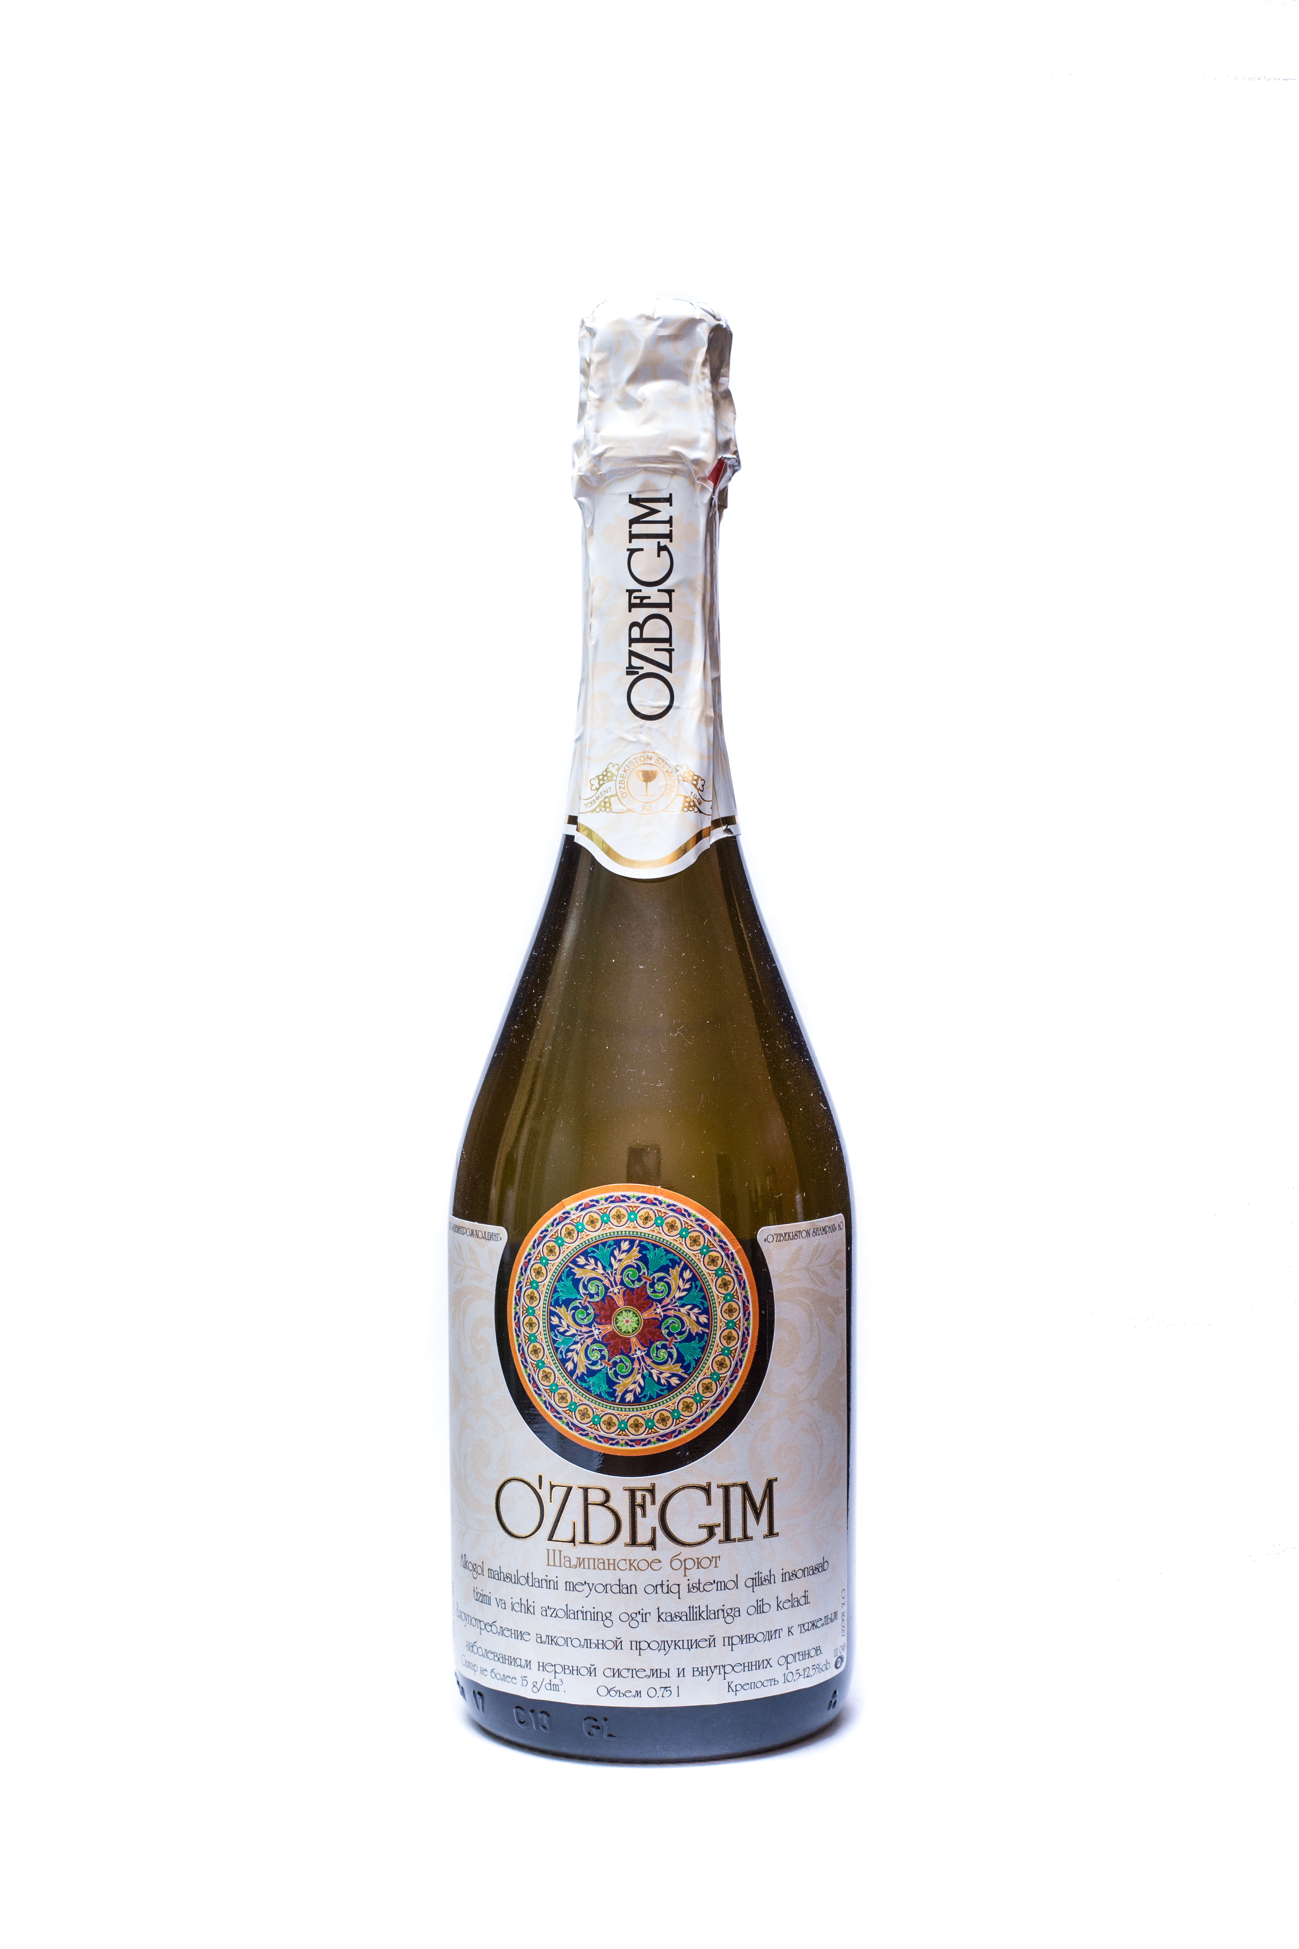 | Uzbek champagne «O`zbegim»  A sparkling wine of high quality is prepared by a periodic asratoforic method from high-quality champagne wine materials, produced from white grapes Bayan-shirei, Rkatsiteli, Kuldzhinskiy, Riesling, in the foothill areas of Uzbekistan, using special champagne yeast. It has a light straw color with light shades of gold and greenery, an elegant floral bouquet and a light harmonious taste, accentuated by the lively play of pearl strings and snow-white lace of foam.  Capacity: 750ml.  Sugar: 5-6 gr / dm3  Fortress: 10-12.5%
 | 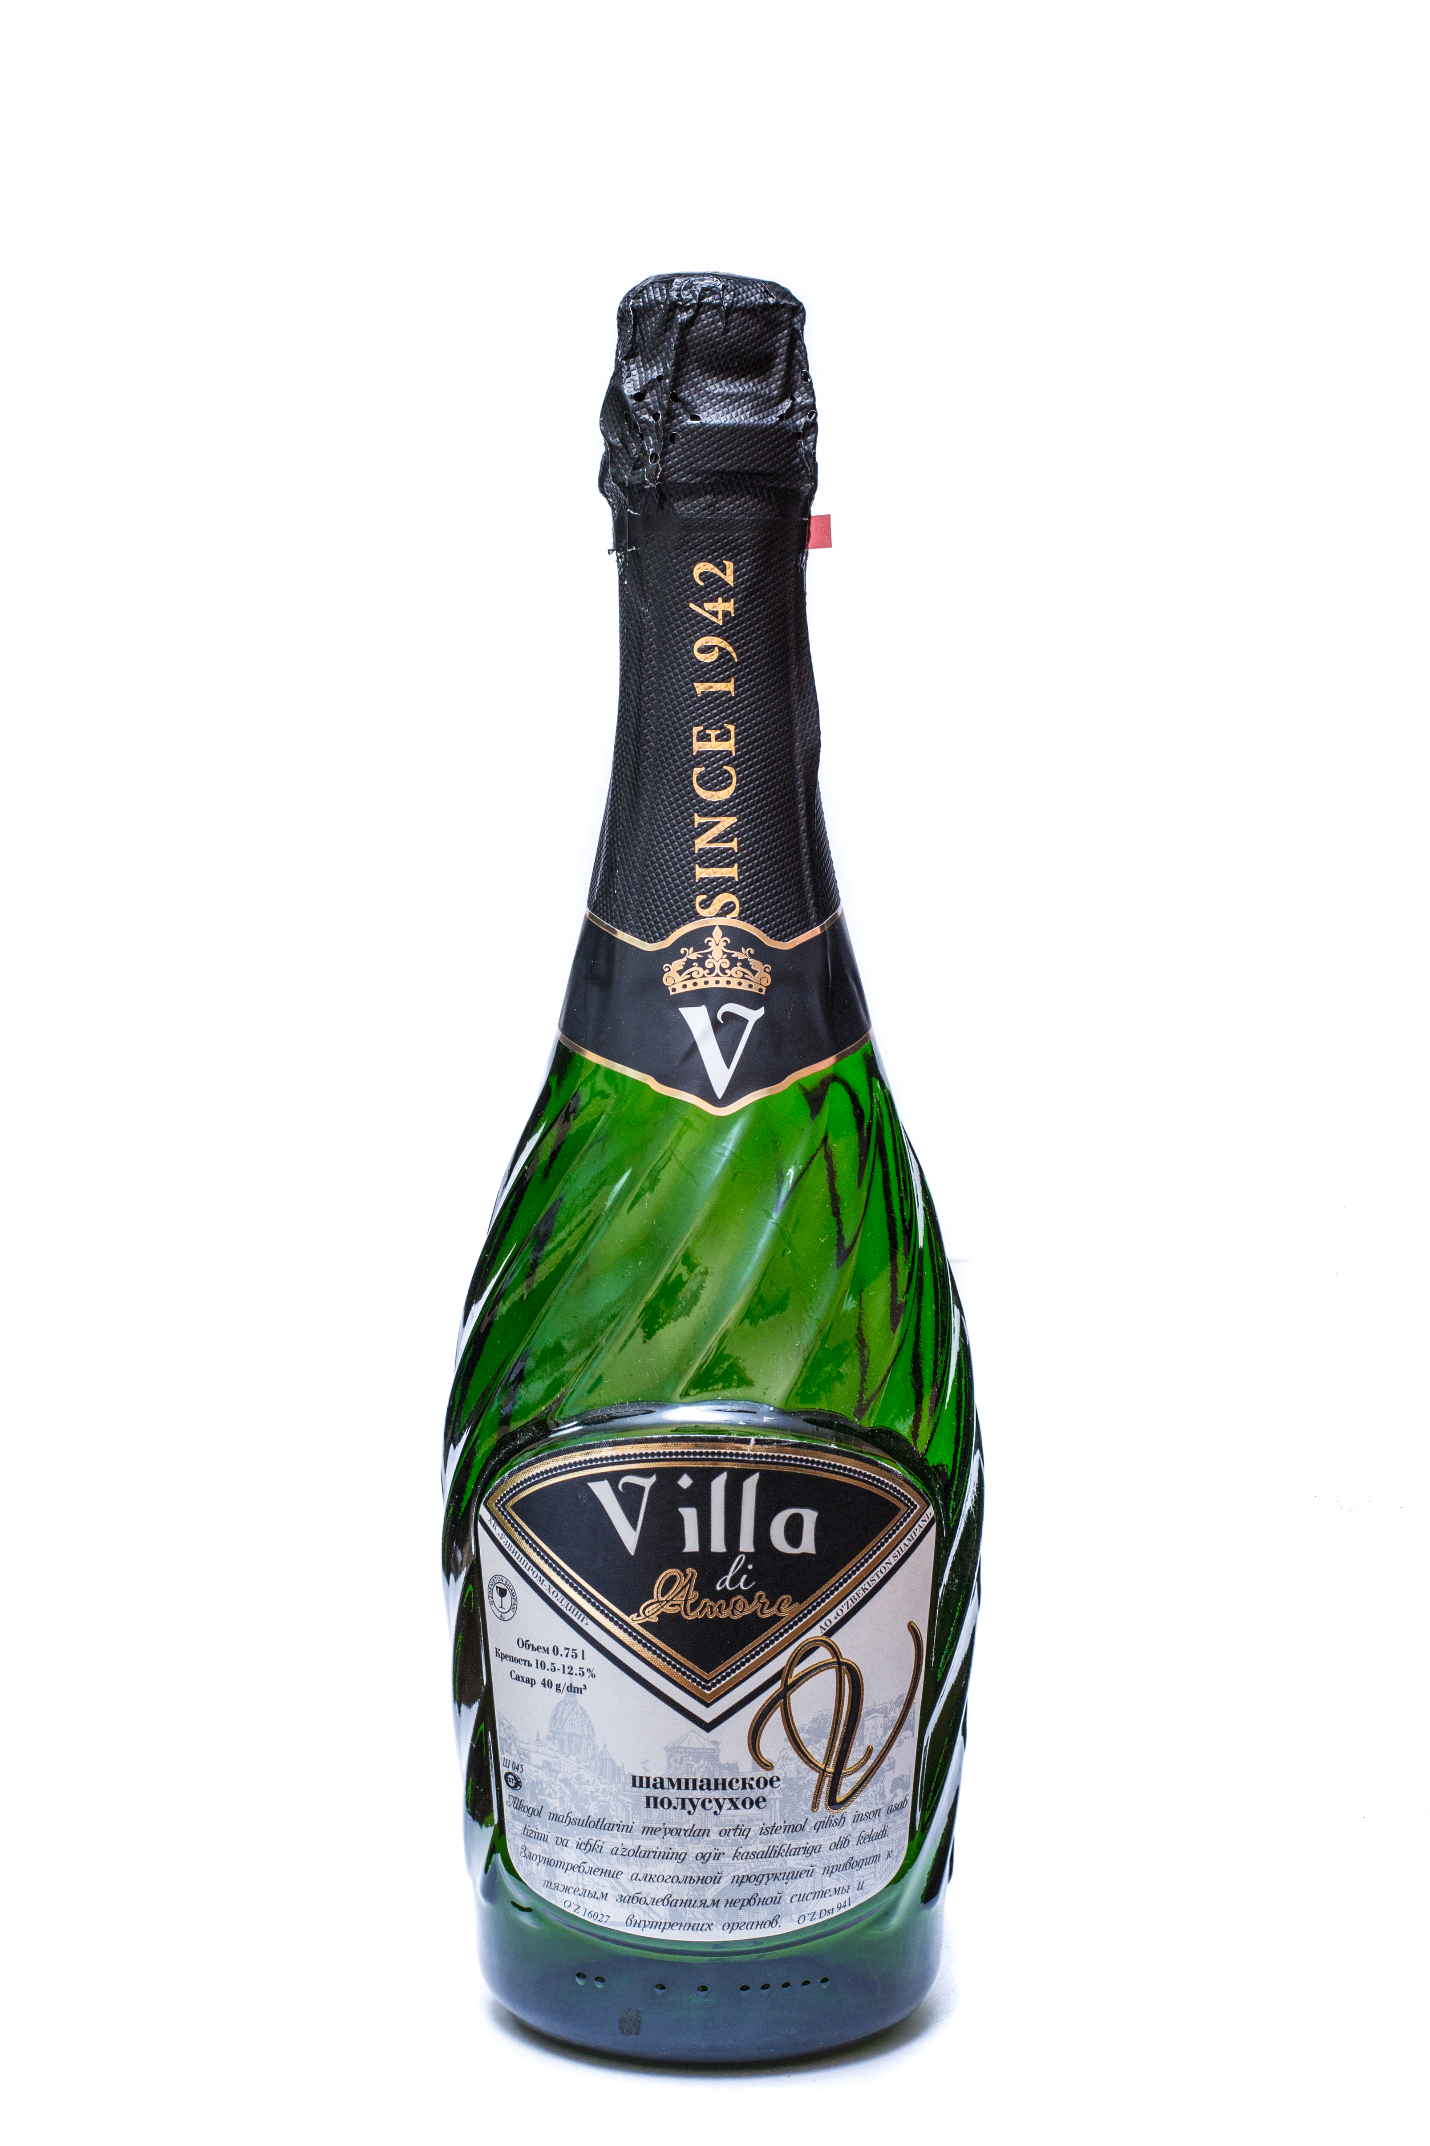 | Uzbek champagne «Villa di amore»  A sparkling wine of high quality is prepared by a periodic asratoforic method from champagne wine materials made from selected grapes of white varieties Bayan-shirei, Rkatsiteli, Kuldzhinsky, Riesling, grown in the foothills of Uzbekistan, using French champagne yeast. It has a light straw color with golden green hues, a complex interesting bouquet of field and garden white flowers, with a slight nutty note and fresh harmonious taste. It has well-pronounced simple and penicidal properties.  The content of sugar produced brands brut, semi-dry and semisweet.  Capacity: 750ml.  Sugar: 40 g / dm3  Strength: 10.5-12.5%
White wine
 | 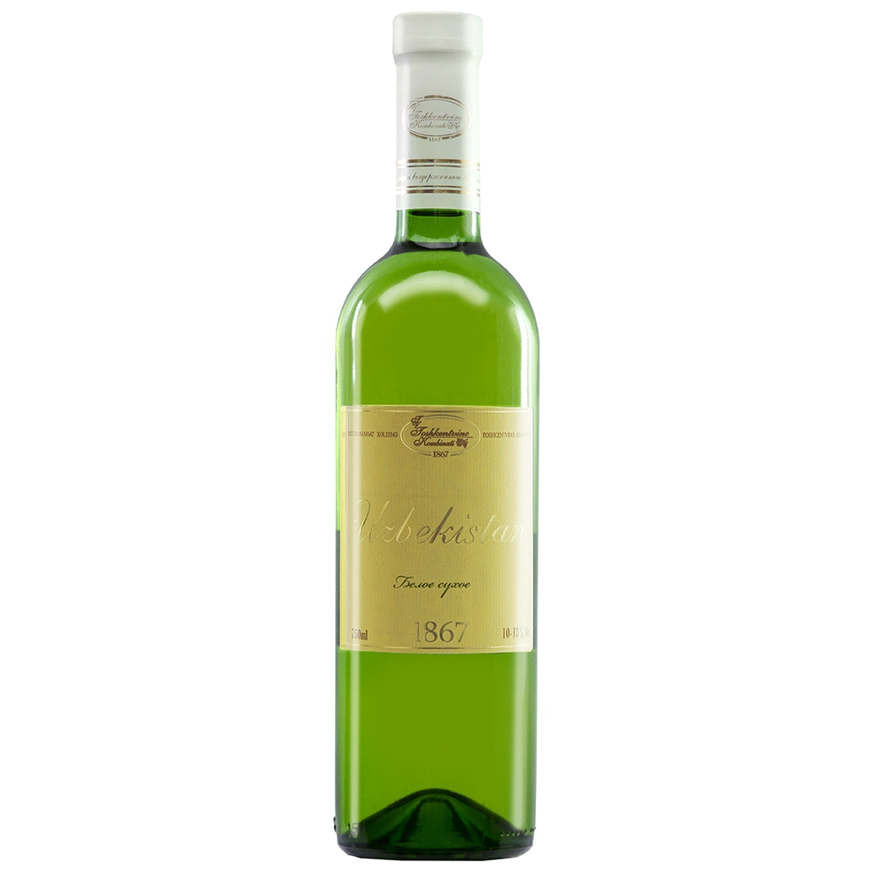 | White dry wine «Uzbekistan»  Produced from the varieties Rkatsiteli and Riesling grapes growing in the Parkent district of Uzbekistan. The color of the wine is light straw with a golden hue. The taste is light, harmonious, with a piquant bitterness in the aftertaste. It has a light floral aroma with honey tints. It is recommended to use at a temperature of 16-18 ° C with vegetable salads, cold appetizers, light cheeses, fruits, as well as fish and white meat.  Capacity: 750ml.  Fortress: 10-13%
 | 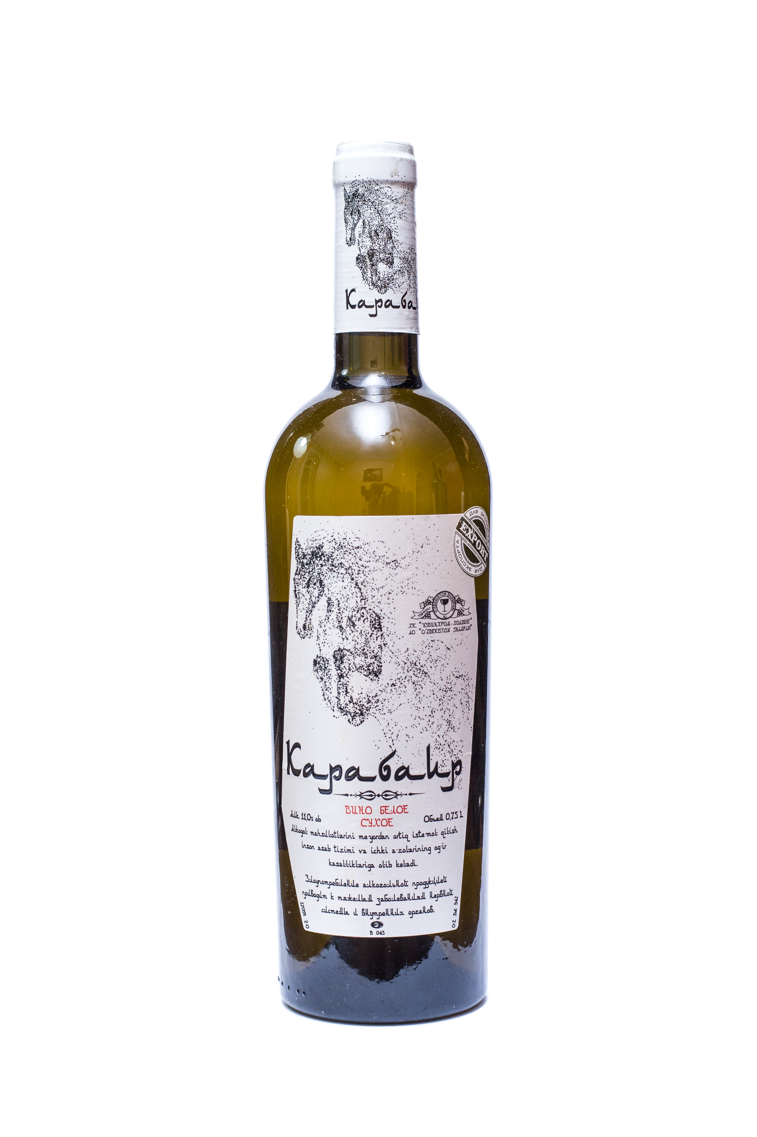 | White dry wine «Karabair»  Karabair is a natural white dry wine made from selected grapes of white varieties Bayan-shirei, Rkatsiteli, Kuldzhinsky, Riesling, grown in the parkent district of Uzbekistan. The wine is straw-colored with greenish golden hues, a complex interesting bouquet with notes of white flowers and honey, a light harmonious taste.  Capacity: 750ml.  Sugar: 4-5 g / dm3  Fortress: 11%
 | 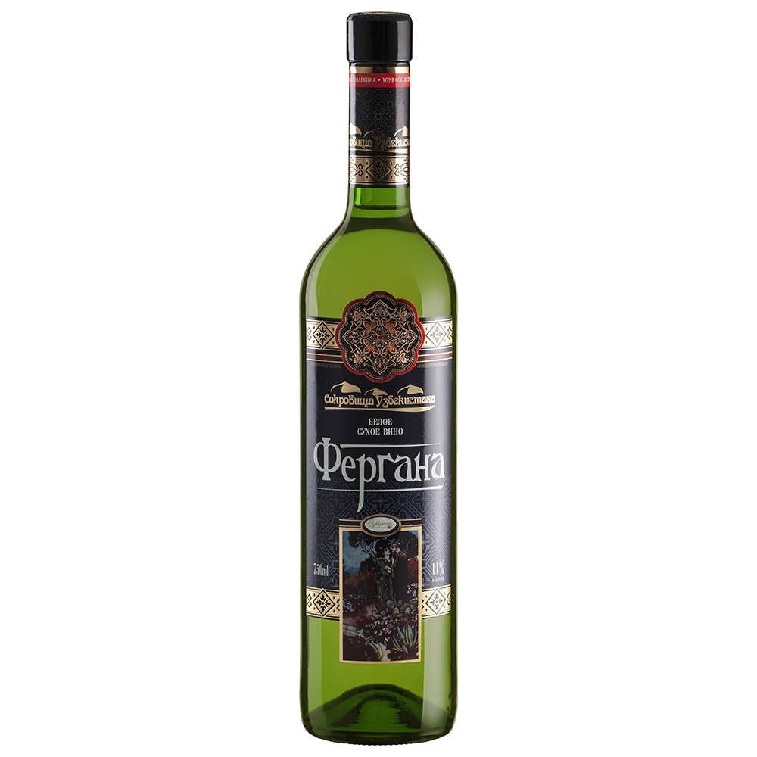 | White dry wine «Fergana»  Produced from the varieties of grapes Bayan Shirei and Muscat Uzbek, growing in the wine regions of Uzbekistan. The color of the wine is light straw with a golden hue. The taste is full, harmonious, with fruity-honey hints. It has a floral-spicy aroma with honey tints. It is recommended to use at a temperature of 5-16 ° C to vegetable salads, cold appetizers, light cheeses, fruits, as well as fish and white meat.  Capacity: 750ml.  Fortress: 11%
 | 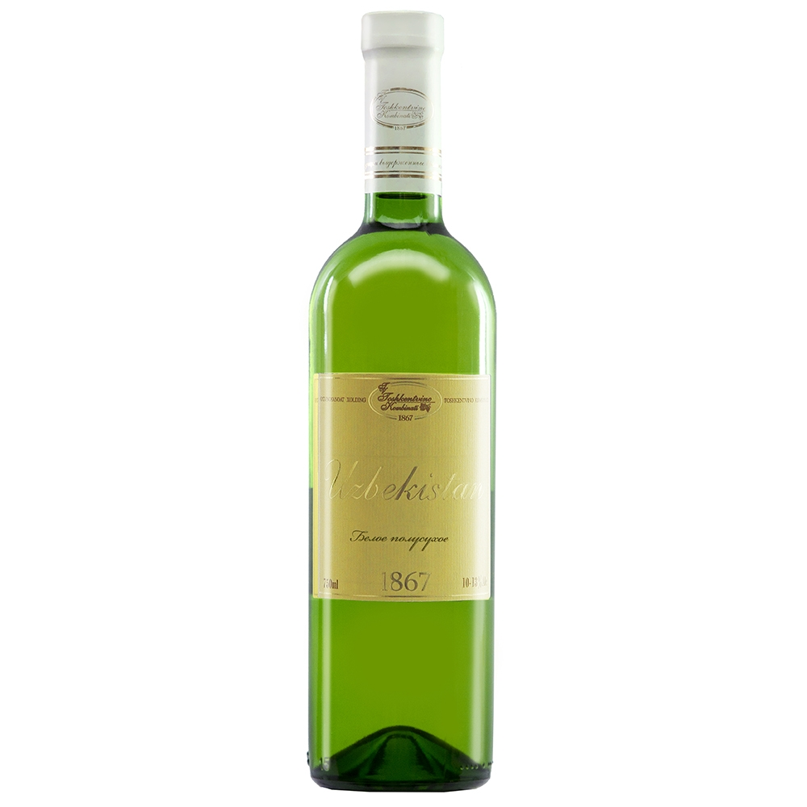 | White semi-dry wine «Uzbekistan»  White semi-dry wine, made from selected white grape varieties Rkatsiteli and Riesling. It has a pleasant bouquet, a floral delicate aroma. The color is light straw with light golden hues. The taste is light and harmonious. Wine can be fed to the second course, and to dessert at a temperature of 2-8 ° C.  Capacity: 750ml.  Sugar: 30g / dm3  Strength: 12%
 | 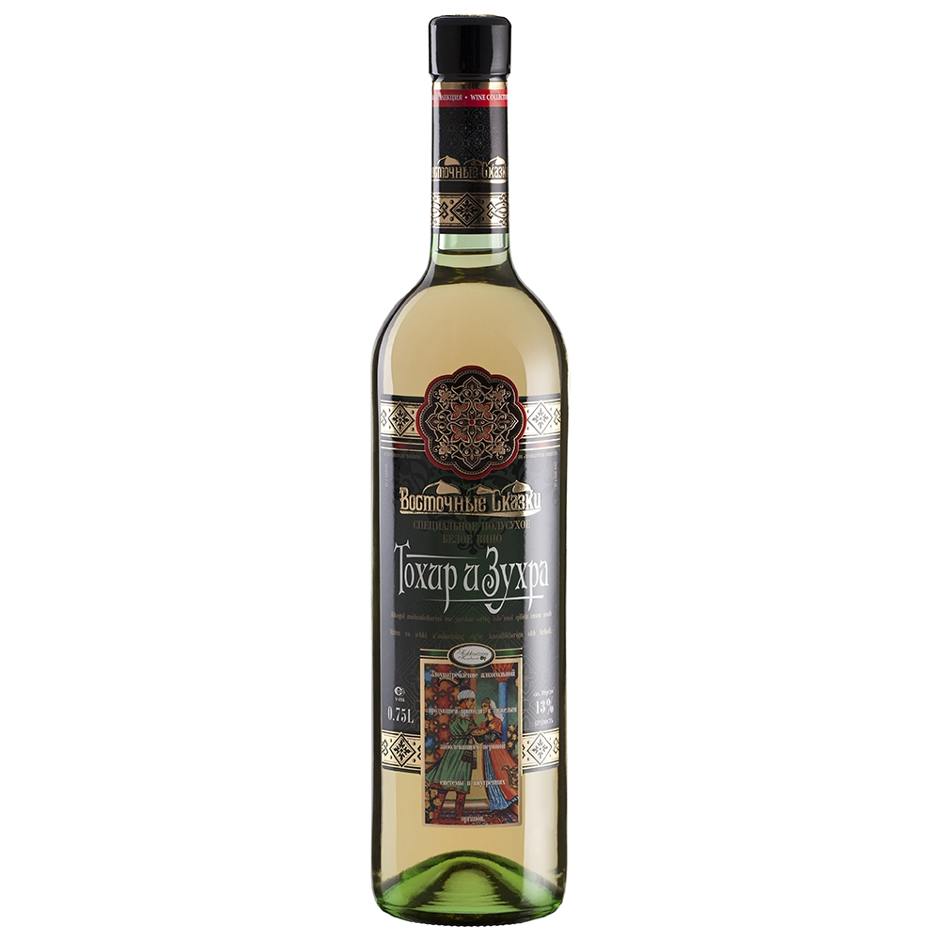 | White semi-dry wine  «Takhir and Zukhra»  Produced from selected white varieties of grapes Rkatsiteli and Soyaki. Has a pleasant bouquet, a floral delicate aroma with honey hints. harmonious taste. Light-green color with light golden hues. The taste is light, harmonious and floral. Wine can be fed to both the second course and to the dessert at a temperature of 2-10 ° C.  Capacity: 750ml.  Sugar: 30g / dm3  Strength: 13%
 | 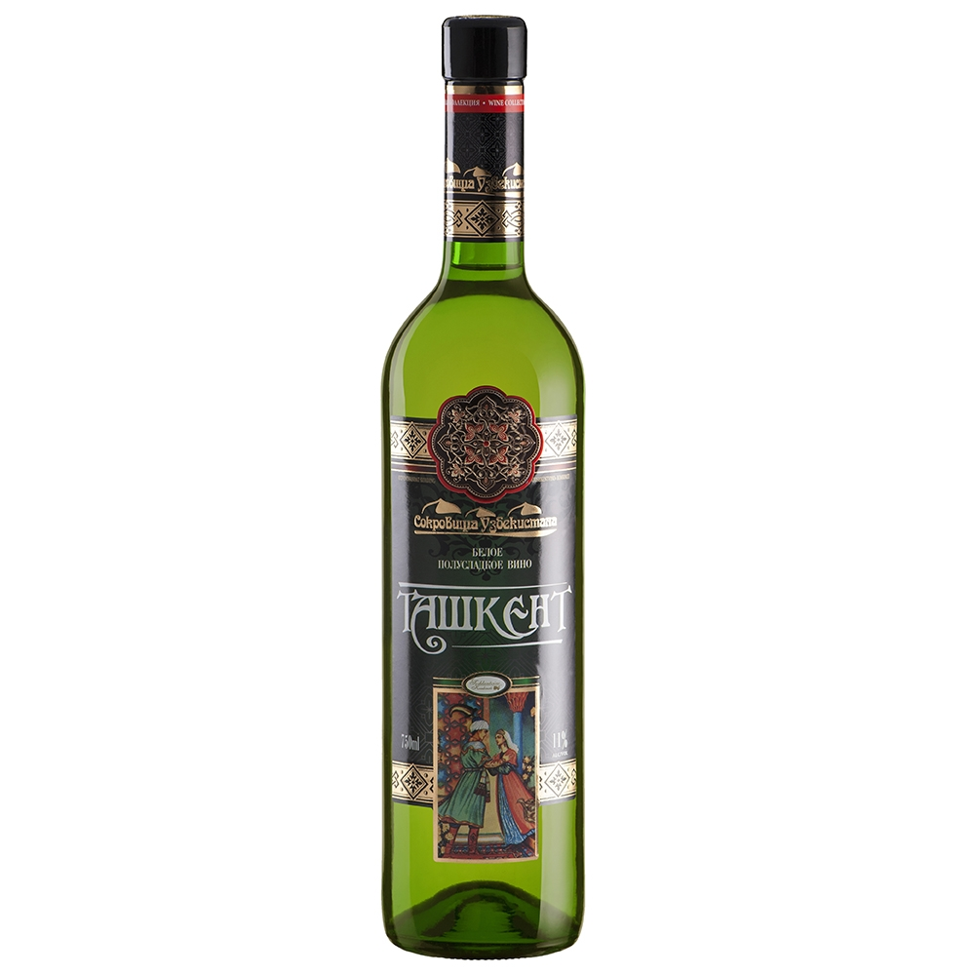 | White semi-sweet wine «Tashkent»  Produced from the varieties of grapes Bayan-Shirei and Rkatsiteli. The color of the wine can be from light straw to light golden. The delicate aroma of wine is revealed by light flower-honey hints. The wine has a harmonious m soft taste with piquant tones. The wine is served at a temperature of 2-8 ° C to vegetable salads, cold appetizers, light cheeses and fruits.  Capacity: 750ml.  Sugar: 40gr / dm3  Fortress: 11%
 | 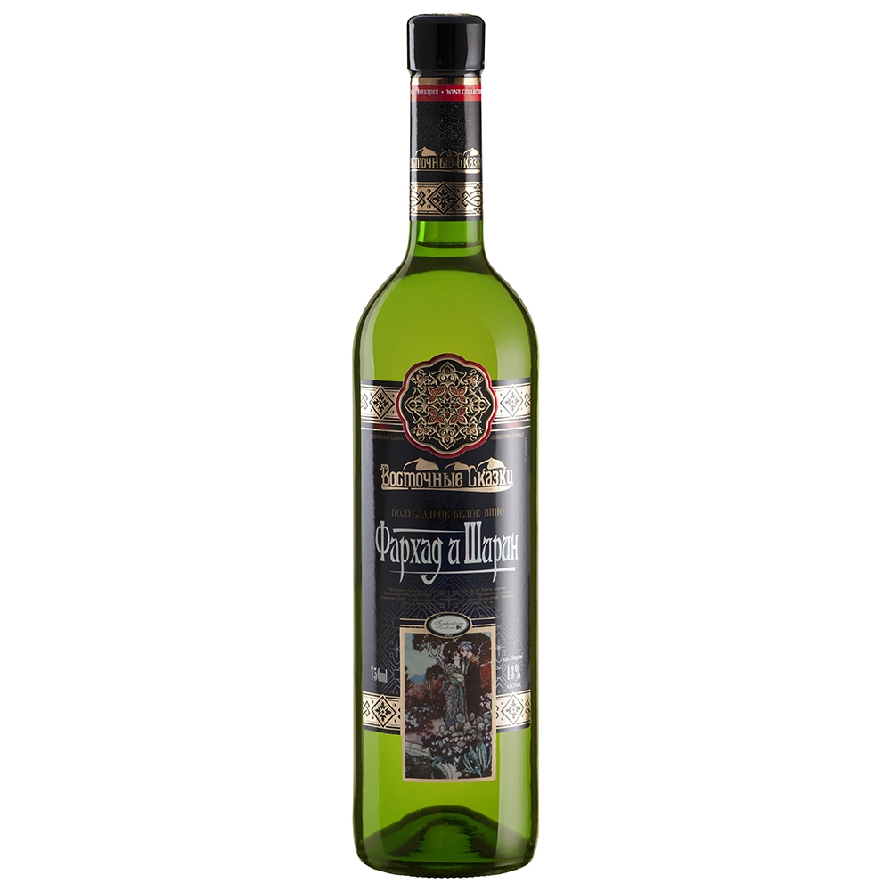 | White semi-sweet wine  «Farkhad and Shirin»  Produced from autochthonous varieties of grapes Bayan-Shirey and Soyaki. The wine is pale golden in color. Delicate aroma of wine reveals pleasant fruit notes. Its aroma is dominated by delicate fruit shades, and the elegant taste is charming with freshness and good balance. The wine has a clean, soft, harmonious taste and fresh aftertaste. Wine is a good complement to a variety of salads, fish dishes, seafood, white meat, spicy dishes and cheeses. The wine is served at a temperature of 2-10 ° C.  Capacity: 750ml.  Sugar: 50g / dm3  Strength: 13%
 | 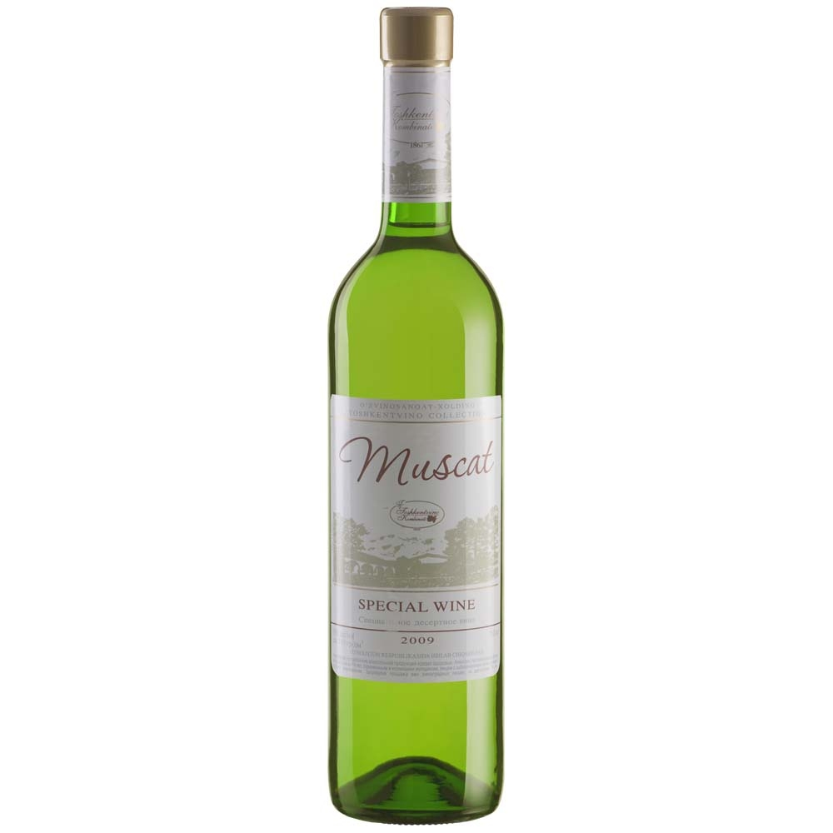 | White desert wine «Muscat»  Muscat wine is made from Muscat Hungarian grape variety, has a delicate honey aroma with shades of petals of the Kazanlik rose. Wine of golden color. The taste is full, harmonious, with the tone of the rose jam. The captivating tenderness of taste and the charm of a fragrant bouquet create an unforgettable impression on this wine. Muscat wine combines well with fruits, confectionery, and is served to a delicious dessert at room temperature.  Capacity: 750ml.  Sugar: 140gr / dm3  Fortress: 15%
 | 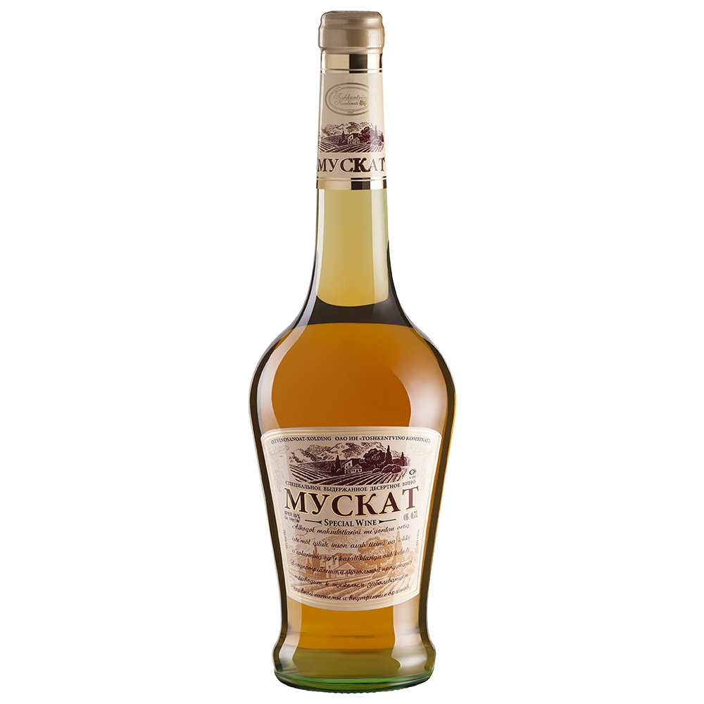 | White desert wine «Muscat»  The wine is made from the Muscat Hungarian grape variety, has a delicate honey aroma with shades of petals of the Kazanlik rose. Wine of golden color. The taste is full, harmonious, with the tone of the rose jam. The captivating tenderness of taste and the charm of a fragrant bouquet create an unforgettable impression on this wine. Muscat wine combines well with fruits, confectionery, and is served to a delicious dessert at room temperature.  Capacity: 700ml.  Sugar: 160 g / dm3  Fortress: 16%
Red wine
 | 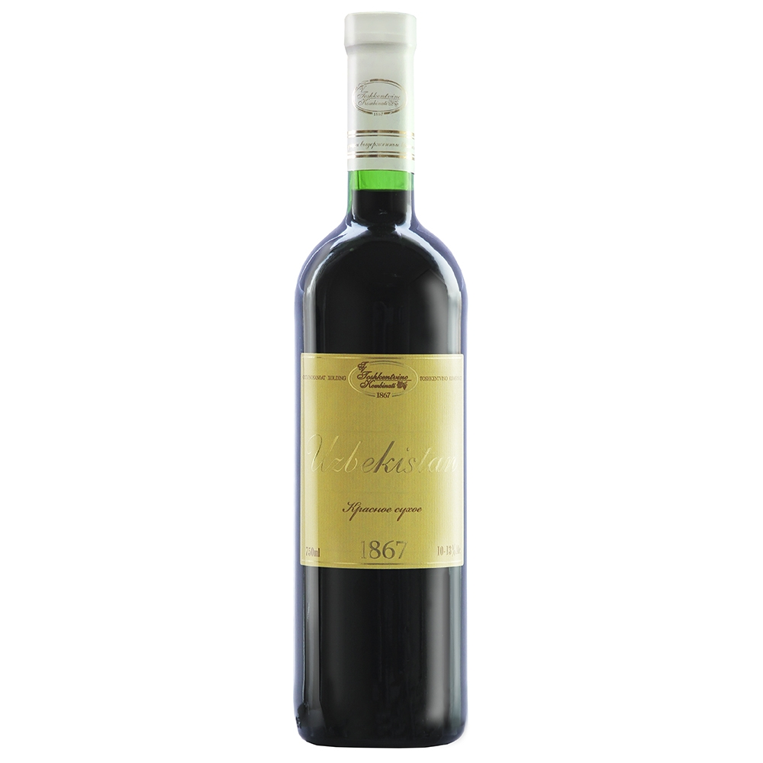 | Red dry wine «Uzbekistan»  Uzbek natural red wine, made from varieties of grapes Cabernet and Tavkveri. The wine has a rich ruby color. It has a pleasant taste and a slight acid content. The aroma is delicate with berry tones. It fits well with dishes with red meat and cheese. It is recommended to use at a temperature of 5-16 ° C.  Capacity: 750ml.  Fortress: 10-13%
 | 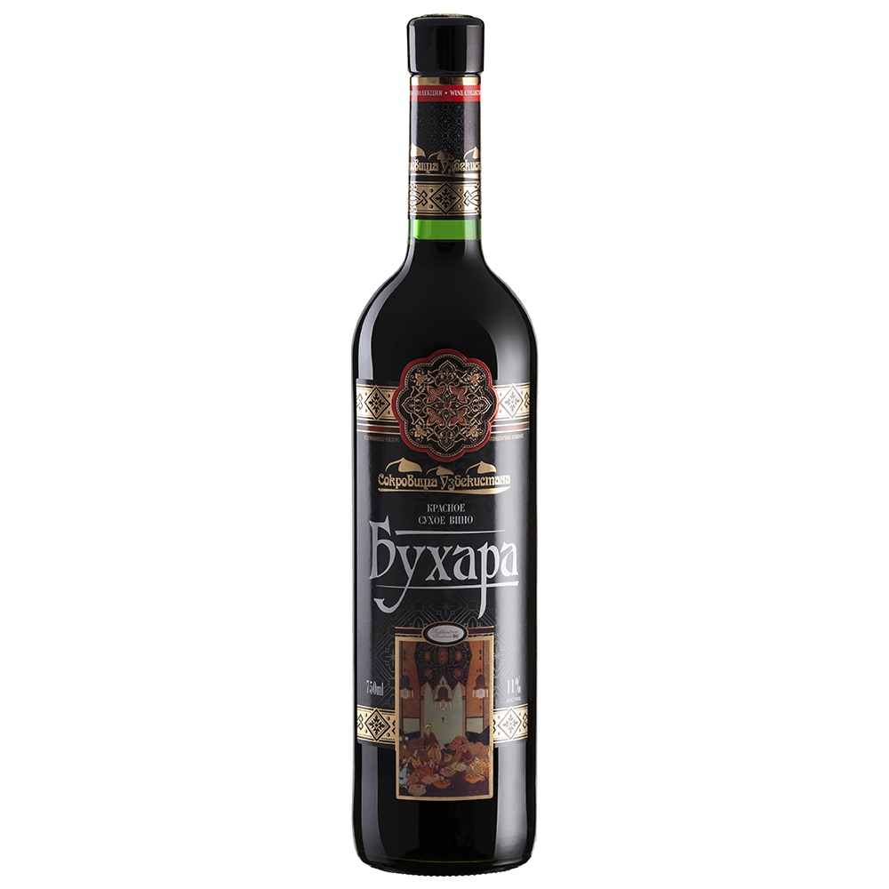 | Red dry wine «Bukhara»  Wine combines the best features of two varieties of grapes grown under the bright sun of Uzbekistan. With its rich coloration, saturation and acidity, the wine is obliged to the Saperavi variety, which is considered to be Georgian, but has perfectly taken root in Uzbekistan. It is complemented by the Cabernet-Sauvignon variety, which gives the fragrance a subtlety and light notes of violets. Both of these varieties are somewhat coarse in their youth, reaching a maximum of their organoleptic properties in 8-10 years. After maturing, the wine significantly improves its taste, showing the elegance and softness of the fruit and berry composition. Dark ruby ​​wine Bukhara has a full, harmonious taste, with moderate tannins and varietal tones. The soft, velvety taste of wine is made up of shades of fruits and berries, in harmony with pleasant acidity. Chilled wine will make a good pair of different meat dishes: grilled meats, grilled meats and meat snacks. Sold at a temperature of 5-16 ° C.  Capacity: 750ml.  Fortress: 11%
 | 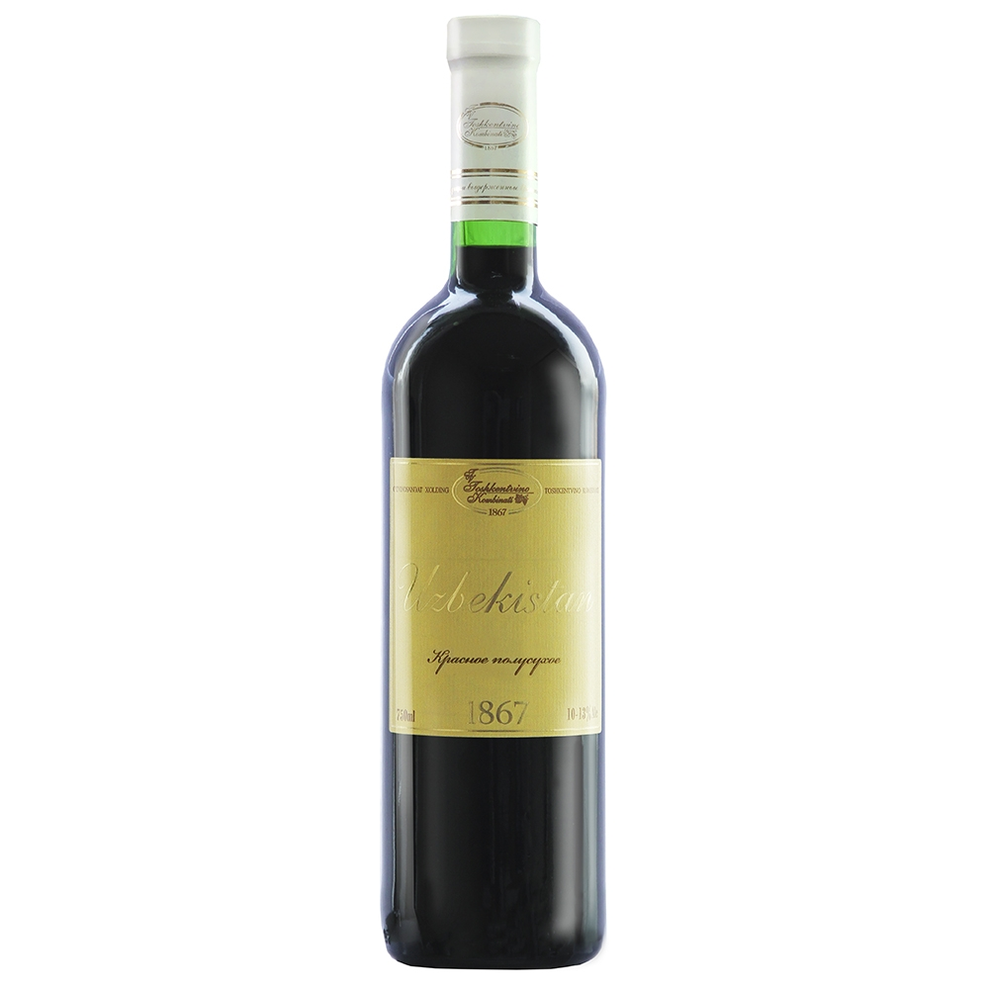 | Red semi-dry wine «Uzbekistan»  Produced from varieties of grapes Cabernet and Tavkveri. The wine has a rich ruby color. It has a pleasant taste and a slight acid content. A delicate aroma with a floral tinge and berry tones. It fits well with dishes with red meat and cheese. It is recommended to use at a temperature of 2-8 ° C.  Capacity: 750ml.  Sugar: 30g / dm3  Strength: 12%
 | 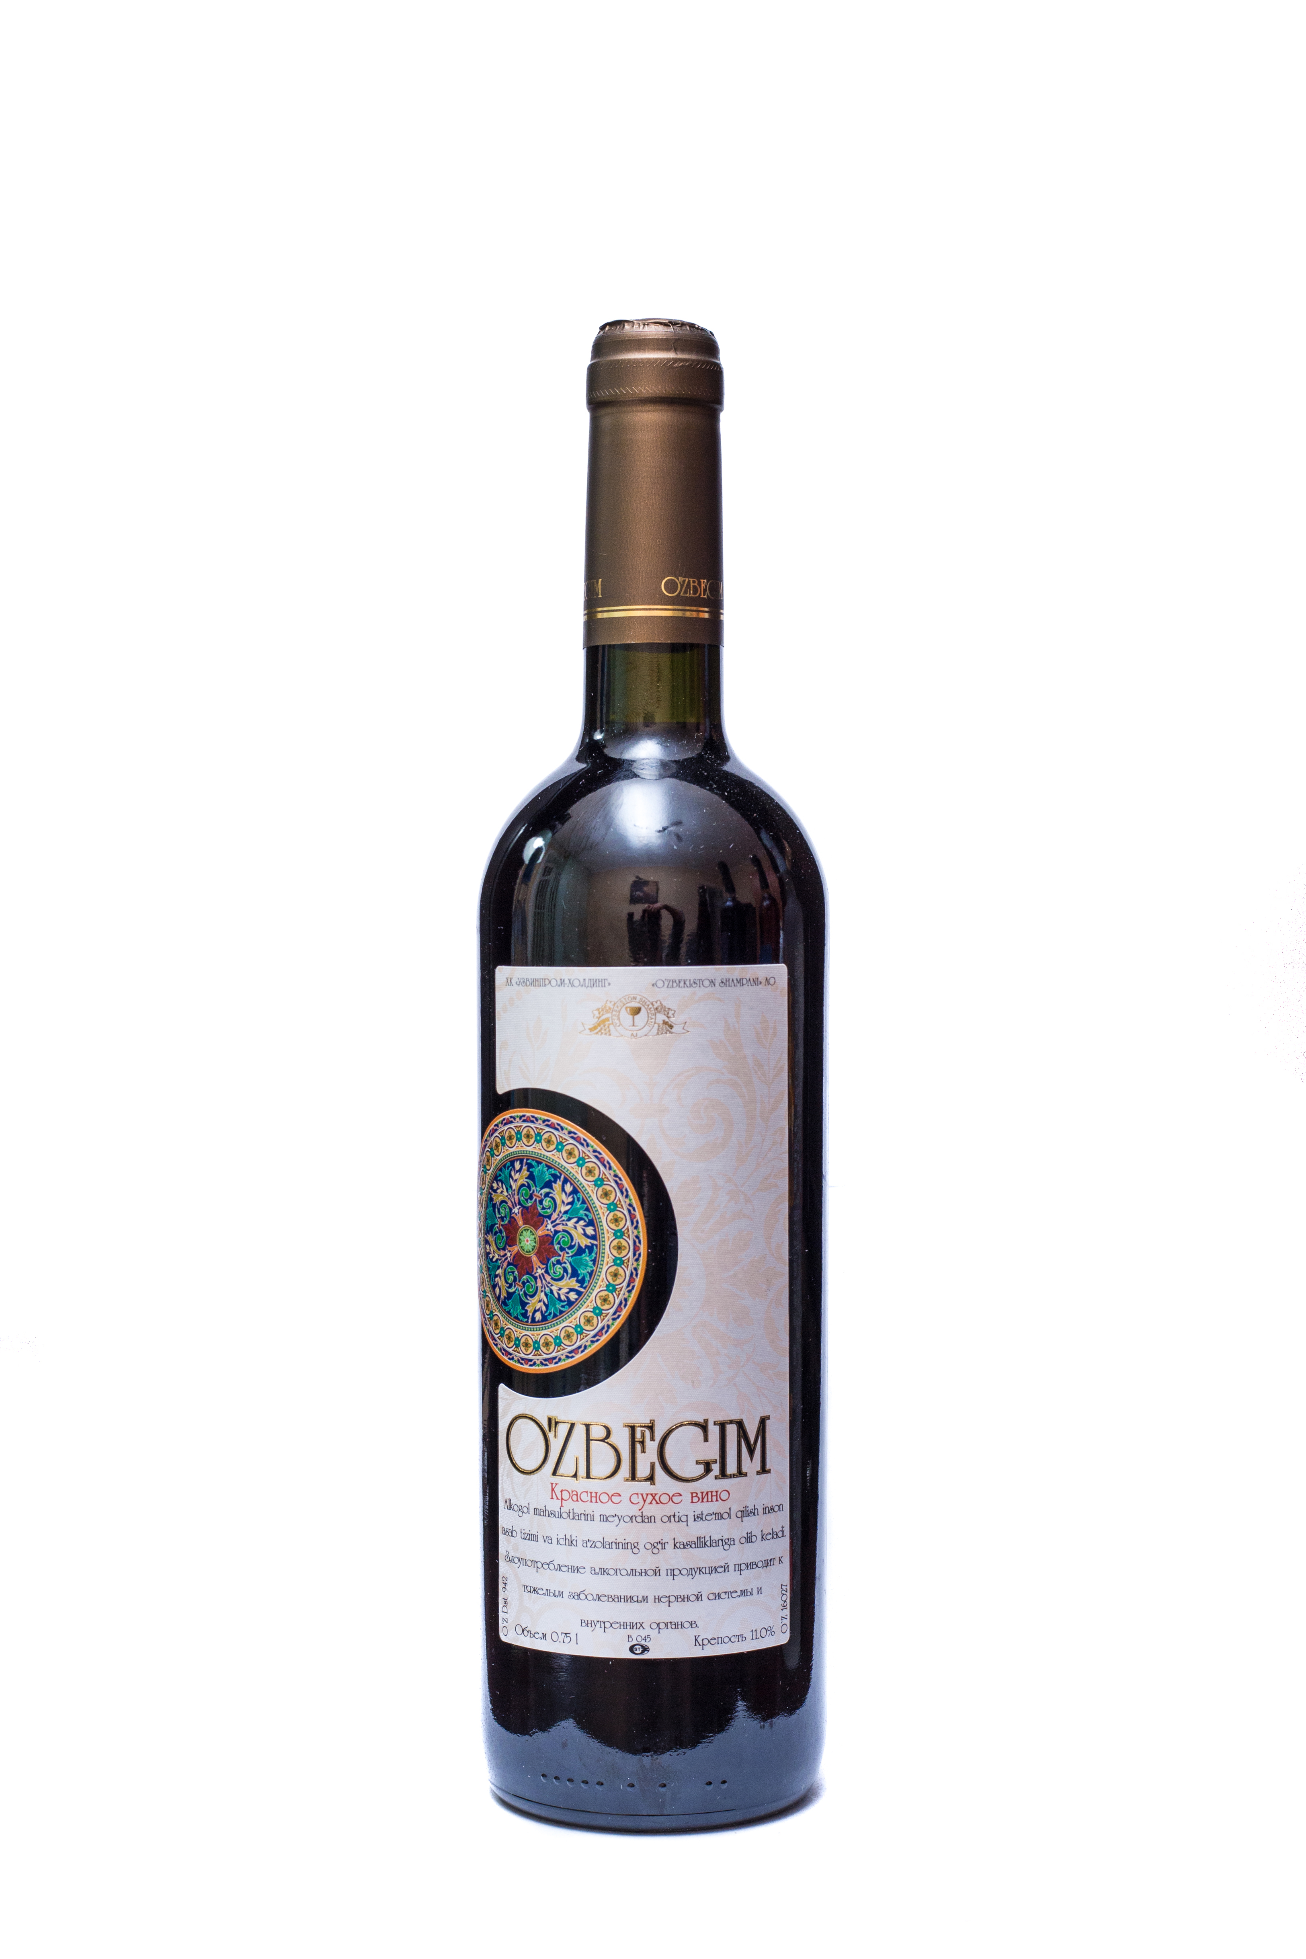 | Red dry wine «O`zbegim»  Natural red dry wine is prepared from the artfully selected blend of wine materials made from red technical varieties of Cabernet and Saperavi grapes, characterized by a rich red color with shades of ruby, rich floral berry bouquet with delicate notes of cherry and currant, soft velvety taste.  It is produced by a fortress of 11% vol. And the acidity of 4-5 g / dm3  Capacity: 750ml.  Sugar: 4-5 g / dm3  Fortress: 11%
 | 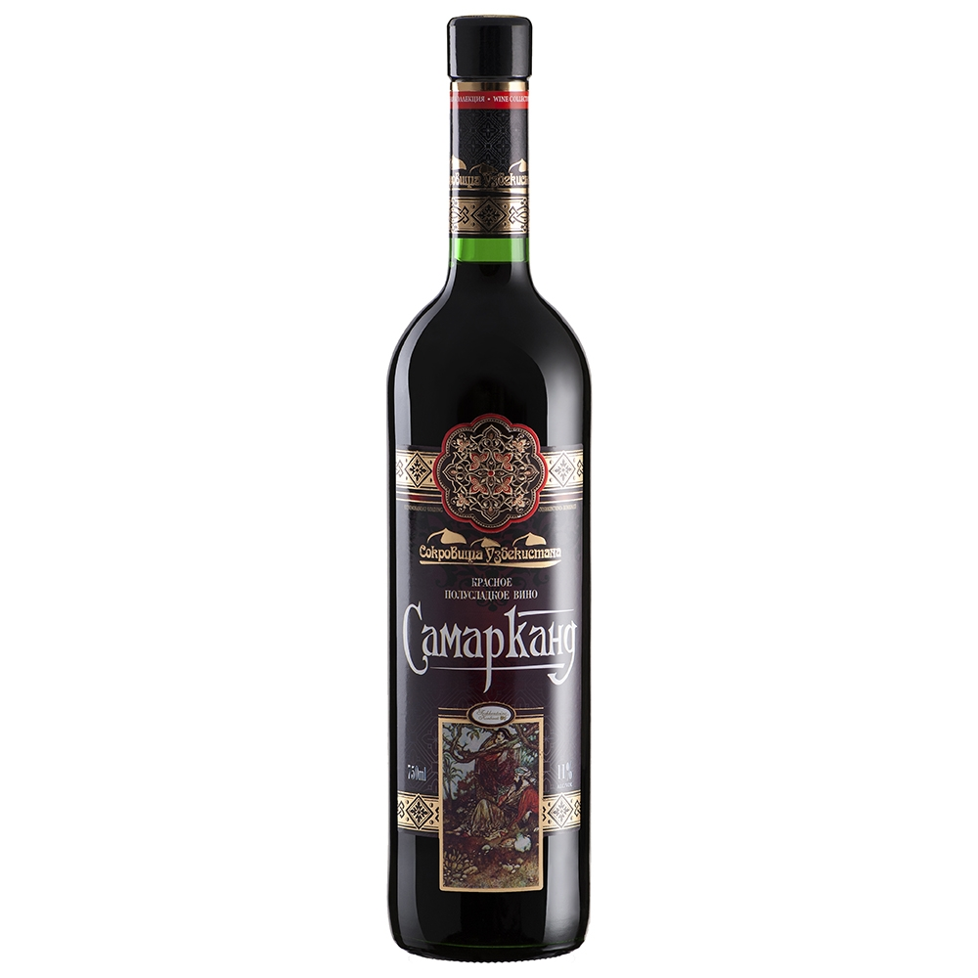 | Red semi-sweet «Samarkand»  Light semi-sweet red wine is created from the selected red grape varieties of Cabernet, Tavkveri and Hindogni. Wine of rich ruby ​​color. Its aroma is dominated by exquisite berry shades, and the soft fruit taste ends with a long, pleasant aftertaste. A colorful and bright label of wine deserves special attention, depicting traditional Uzbek motifs. Chilled wine fits well with red meat - fried or grilled, as well as with cheeses and fruits. Serving temperature: 2-10 ° С  Capacity: 750ml.  Sugar: 40gr / dm3  Fortress: 11%
Red semi-sweet «Sem krasavic »
Light semi-sweet red wine is created from the selected red grape varieties of Cabernet, Tavkveri and Hindogni. Wine of rich ruby ​​color. Its aroma is dominated by exquisite berry shades, and the soft fruit taste ends with a long, pleasant aftertaste. A colorful and bright label of wine deserves special attention, depicting traditional Uzbek motifs. Chilled wine fits well with red meat - fried or grilled, as well as with cheeses and fruits. Serving temperature: 2-10 ° С
Capacity: 750ml.
Sugar: 40gr / dm3
Fortress: 11%
 | 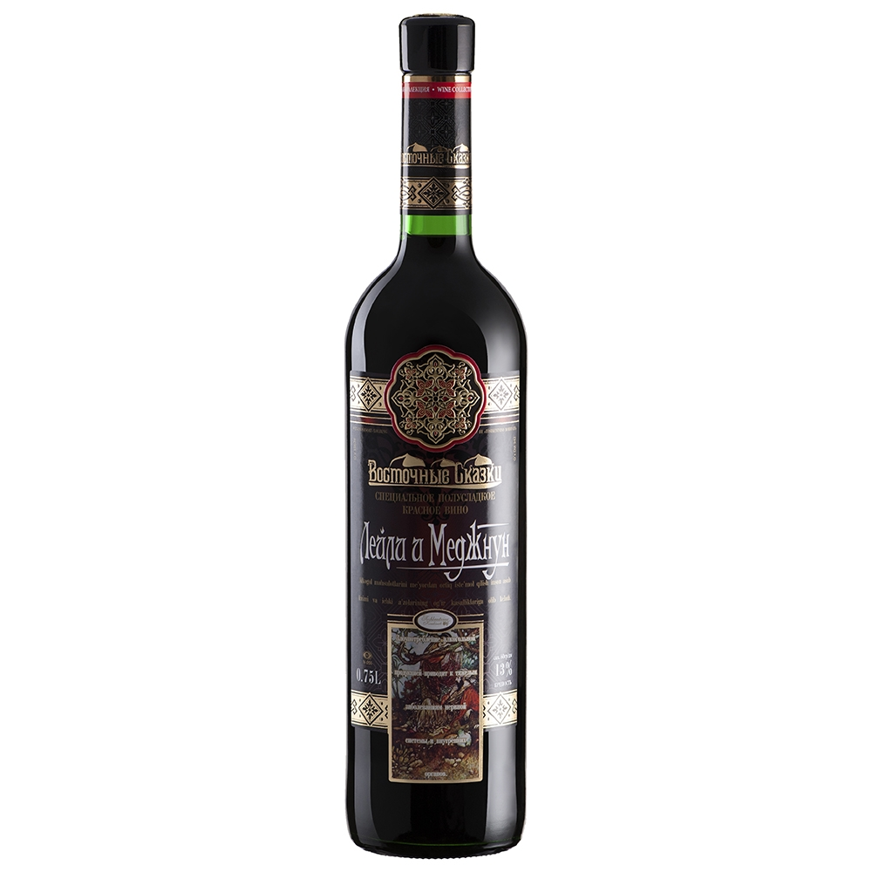 | Red semi-sweet «Layli and Medjnun»  Produced from the varieties of grapes Cabernet, Saperavi and Hindogna. Has a transparent, ruby-red color. It has a pleasant taste and a slight acid content. Fruity aroma of red berries, red and black currants with spicy notes. Wine is easy to drink, round, very soft. Delicious in itself, this wine is also an excellent accompaniment to red meat, casseroles and cheeses. It is recommended to serve at a temperature of 5-10 ° C.  Capacity: 750ml.  Sugar: 60gr / dm3  Strength: 13%
Cognac
 | 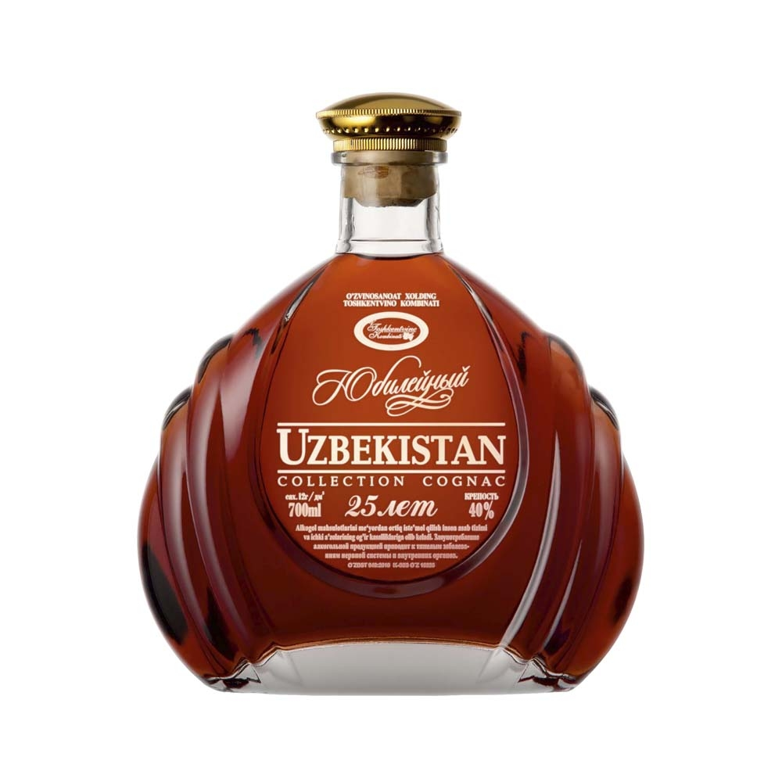 | «Uzbekistan Jubilee»  collection cognac, 25 years aged  This cognac contains the finest eaux-de-vie, the most exclusive in our region, that have been aged in our warehouses for over two decades in oak barrels. 25 years is the perfect time for these specific eaux-de-vie to develop their full richness and heightened aromatic style. Cognac Uzbekistan fascinates due to the way it perfectly balances elegance and exquisite harmony with the full-bodied aroma and characteristic strength of particularly old distillates. On the palate, the aromatic notes deepen into candied orange and gingerbread, leading to a smooth and voluptuous finish with exquisite depth that seems to go on forever.
 | 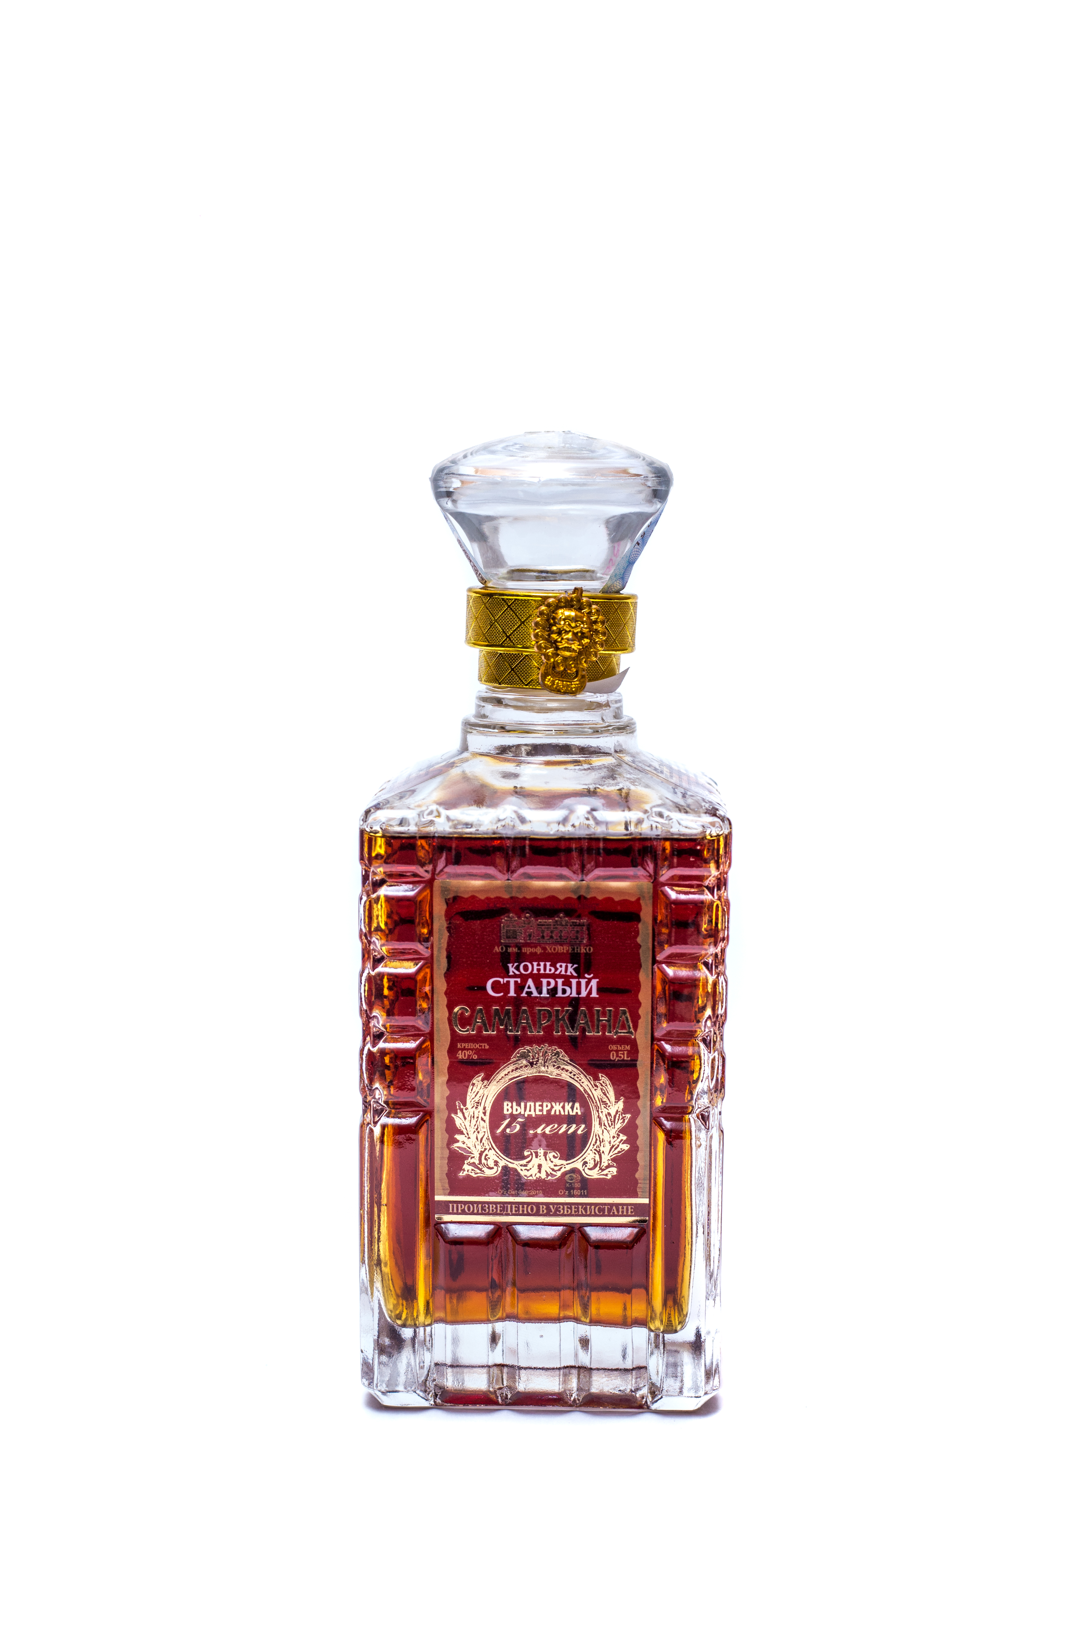 | «Old Samarkand» collection cognac  Cognac "Old Samarkand", cognac group CBS (cognac is very old) is prepared according to the classical technology from cognac spirits, aged in oak barrels for at least 15 years. It has the color of a noble cognac. An exceptionally full bouquet with tones of fresh oak and nutmeg. Harmony and a well-developed bouquet with a complex complex of flavors are combined in it with a mild taste  Aroma-complex, well-coordinated with resinous vanilla tones.
 | 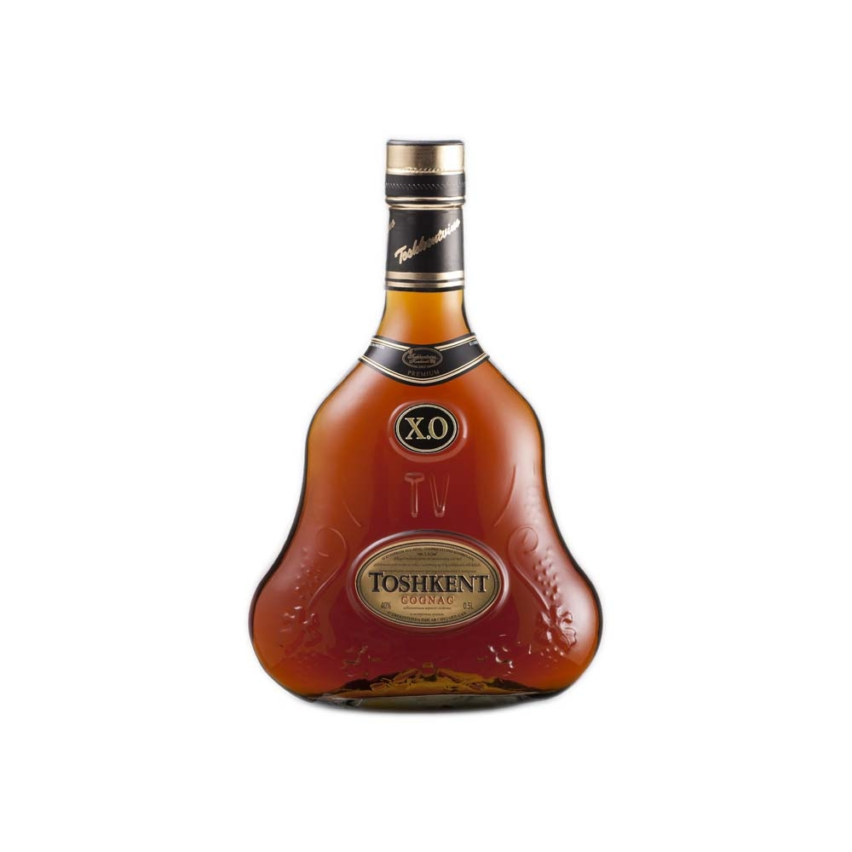 | «Toshkent XO»  premium cognac, 15 years aged  This is an ordinary wine brandy. It is made by the traditional methods of production. Light and delicate, this wine brandy reveals a complex and well-balanced bouquet progressively to both the nose and the palate. The pleasure of tasting.
 | 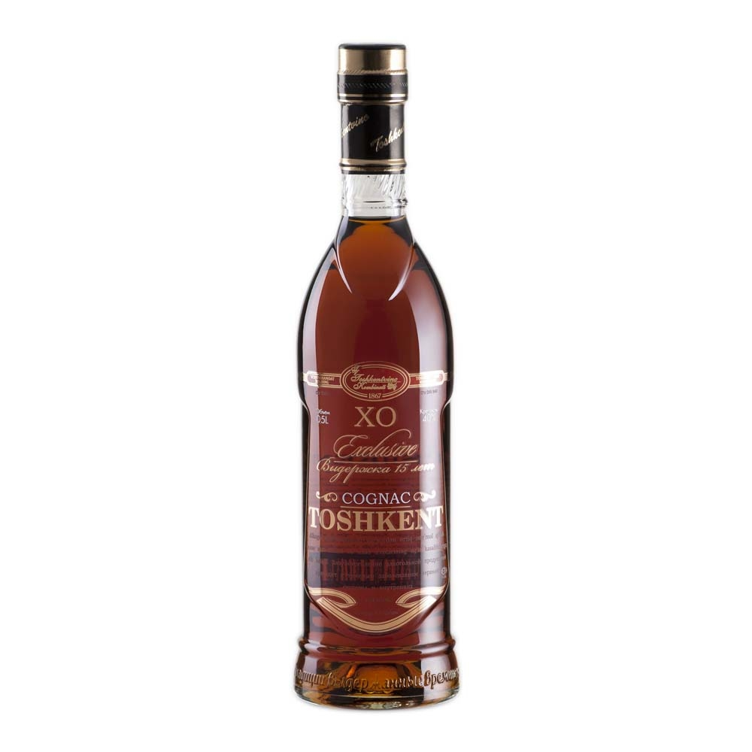 | «Toshkent XO Exclusive»  15 years aged cognac  Deep gold amber, full and powerful, hints of almond and vanilla with a long aftertaste. Every drop is made from rare eaxu-de-vle, aged in our cellars for long 15 years. But believe us, it is more than worth the wait. Rich, full-bodied and complex, TOSHKENT EXCLUSIVE combines the spicy aromas of oak and leather with the sweeter essences of flowers and ripe fruit.
 | 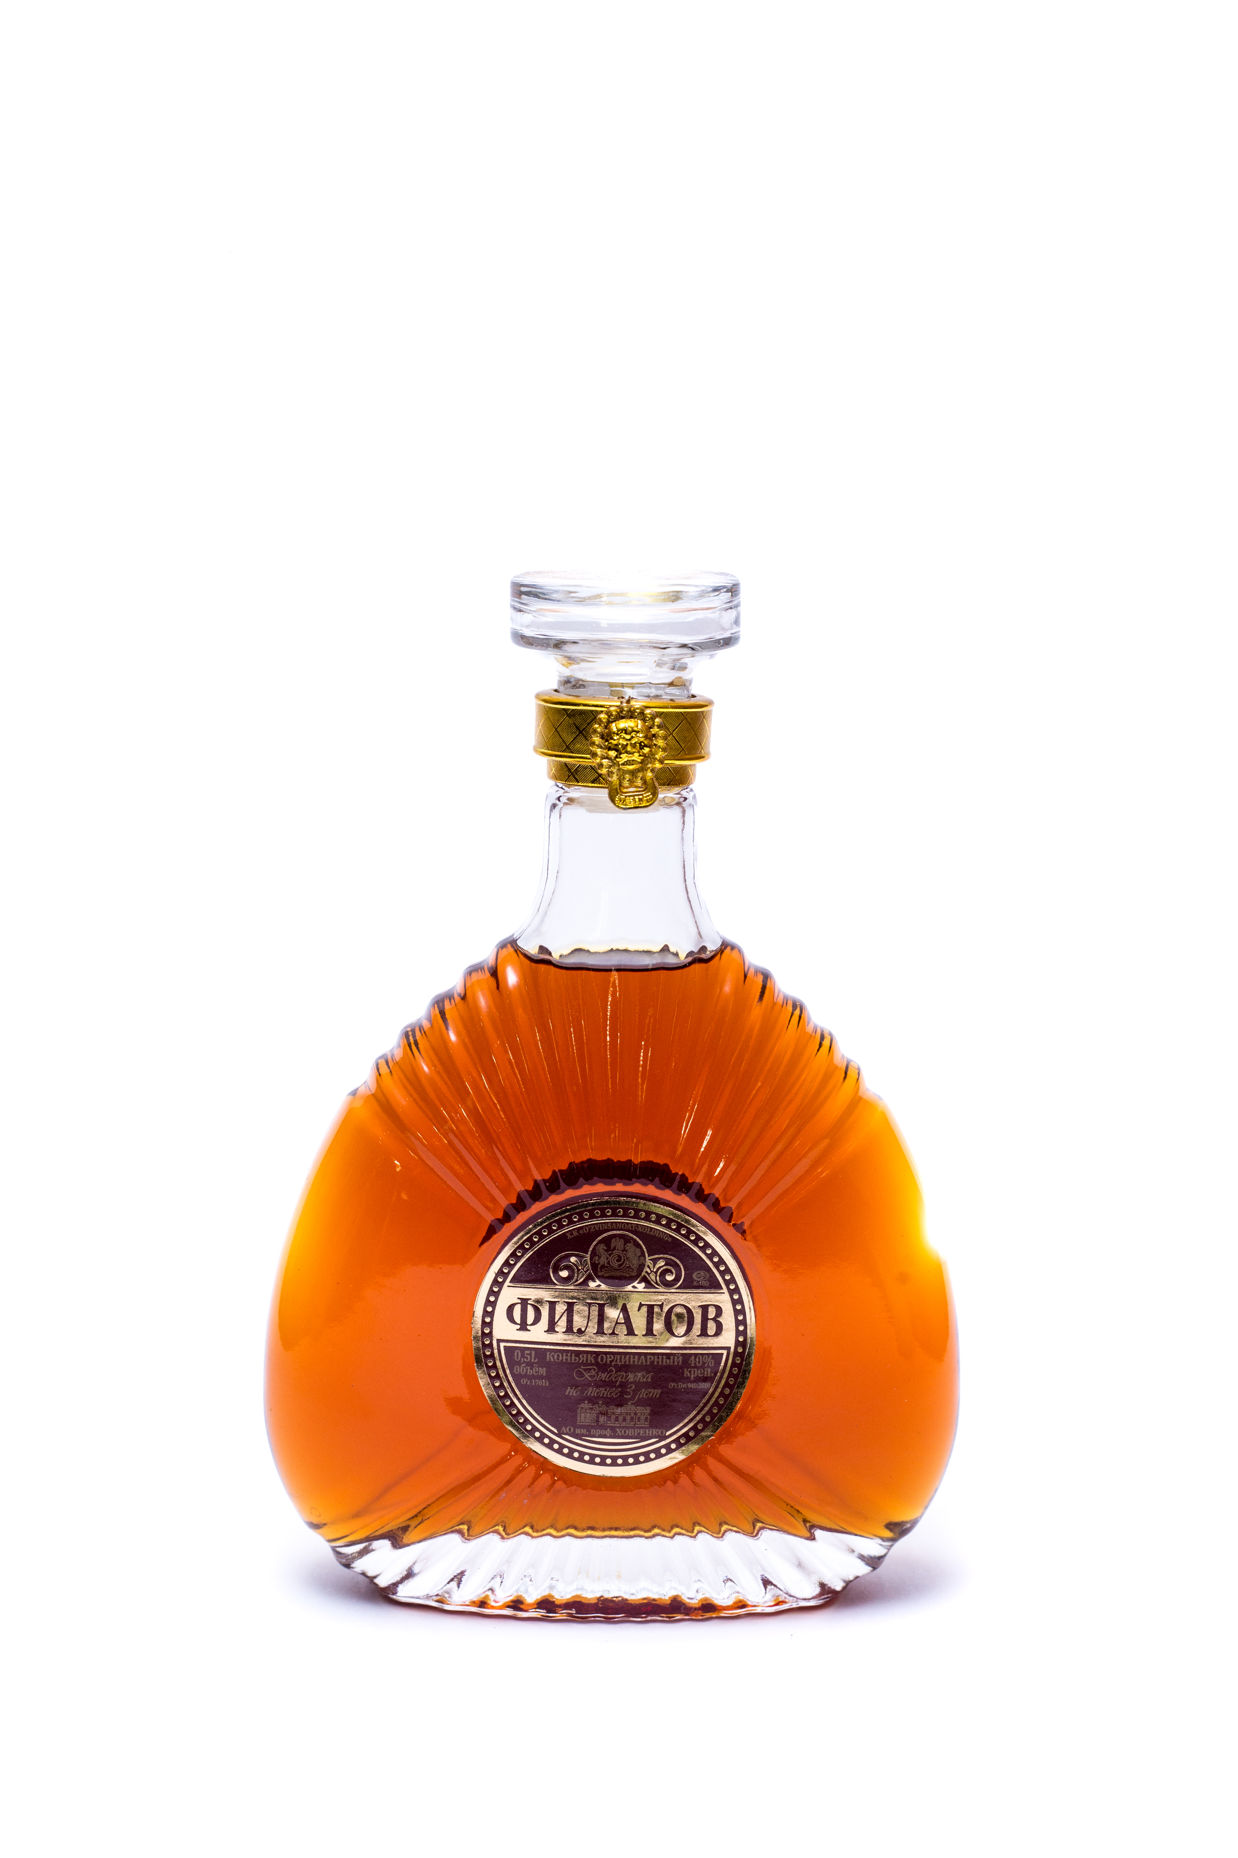 | «Filatov» 3 years aged cognac  Cognac "Filatov", prepared according to the classical technology by blending cognac spirits, aged in oak barrels for at least 3 years. This cognac is characterized by a developed aroma with soft vanilla tones. The taste is slightly burning, rich, multilayered, with a good aftertaste. The color of the cognac is amber, with a clear sheen. The aroma is rich, enchanting, in which the woody aroma perfectly combines with the ease of ripe grape shades.  Invigorating, but soft enough.
 | 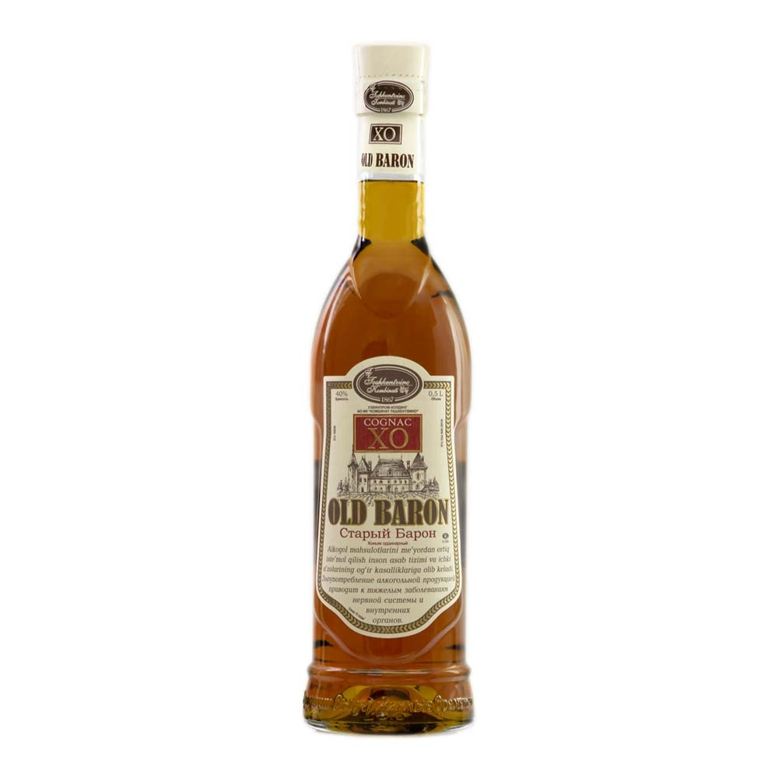 | «Old Baron» ordinary cognac  Old Baron– this is an ordinary wine brandy. It is made by the traditional methods of production. Light and delicate, this wine brandy reveals a complex and well-balanced bouquet progressively to both the nose and the palate. The pleasure of tasting.
Vodka
 | 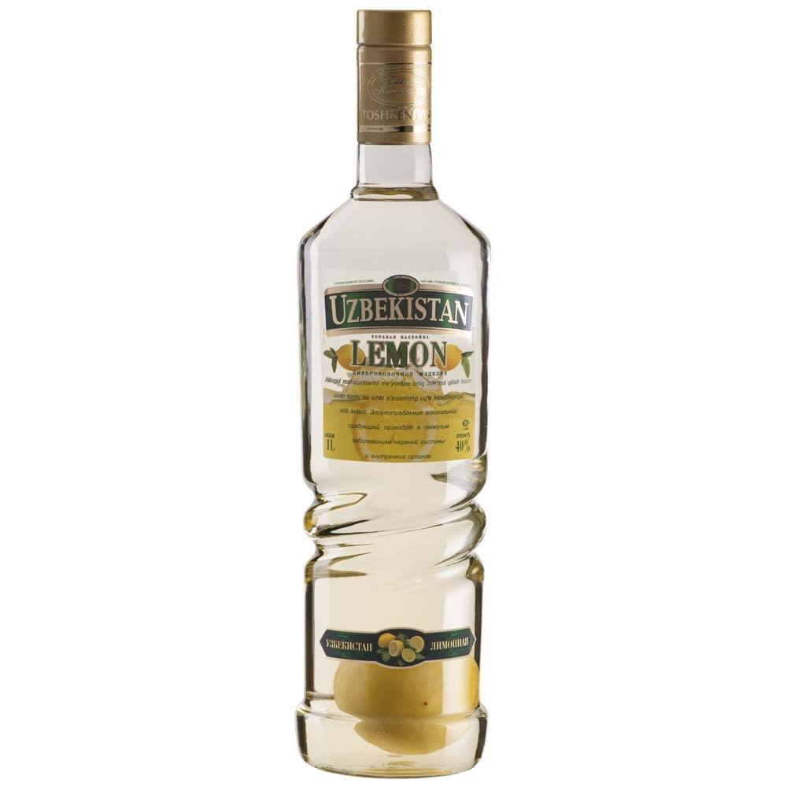 | "Uzbekistan Lemon"  Liqueur-vodka  "Uzbekistan Lemon" is a unique alcoholic beverage product. Inside the bottle contains a natural, whole lemon. This drink is prepared according to a special technology with the use of high-quality "Lux" alcohol.
 | 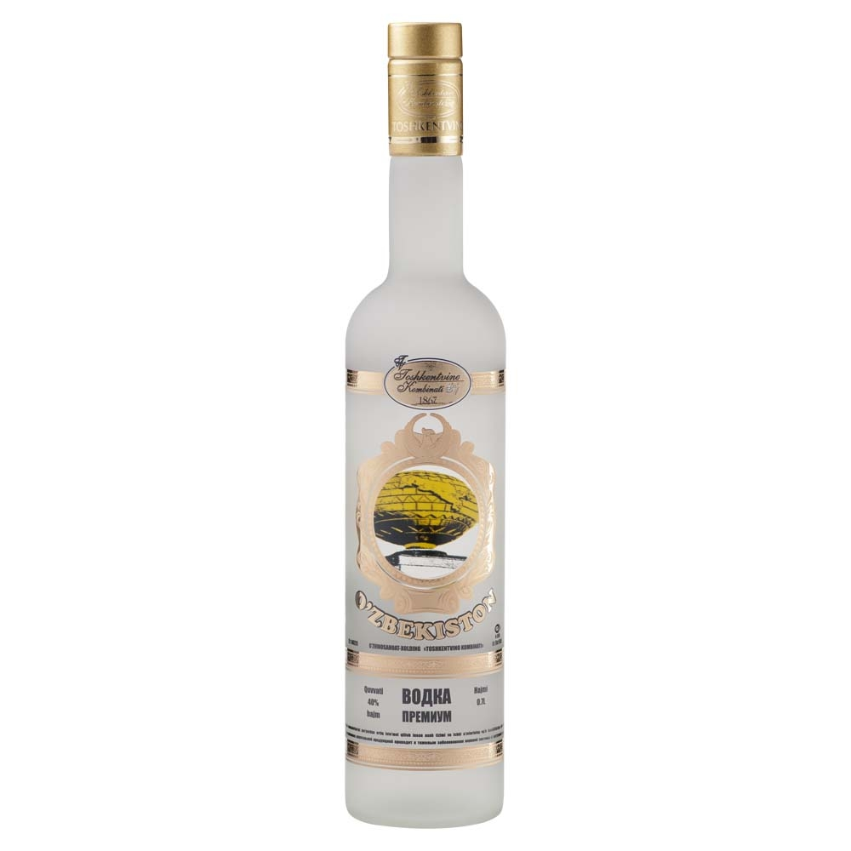 | Vodka "O`zbekiston"  "O'zbekiston premium" - Premium vodka, manufactured according to classical technology from high-quality spirit of "Lux" brand and specially purified water. "O'zbekiston" - it means its naturalness and clean, bright taste.
 | 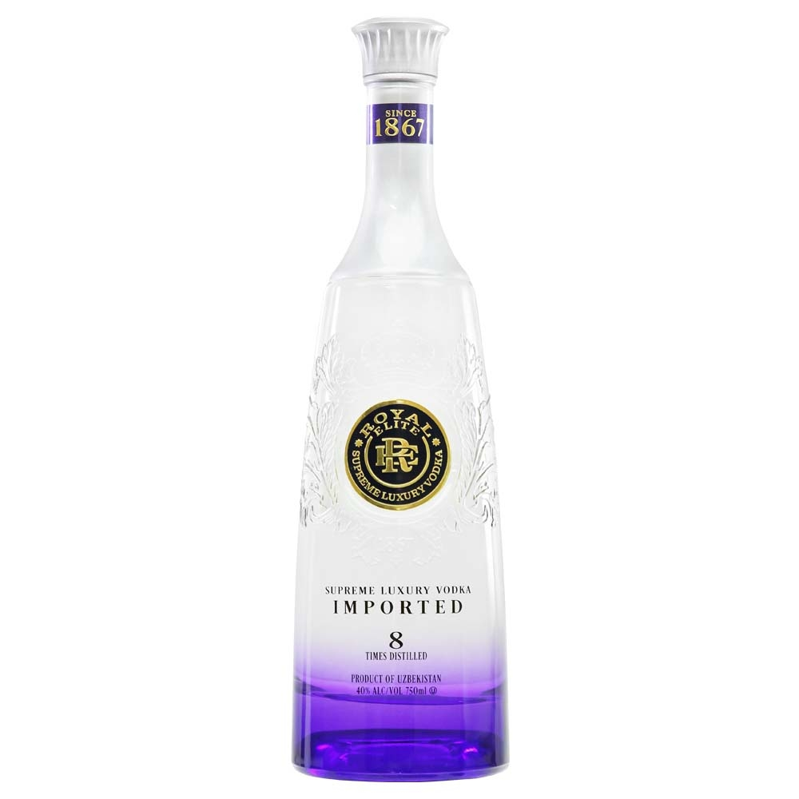 | Vodka "Royal Elite Supreme Luxury Vodka"  Royal Elite Purple Label "Supreme Vodka" is considered one of the best quality vodkas available on the market today. Royal Elite Purple Label "Supreme Vodka" passed eight stages of cleaning with modern equipment installed at the Tashkentvino Combine.
 | 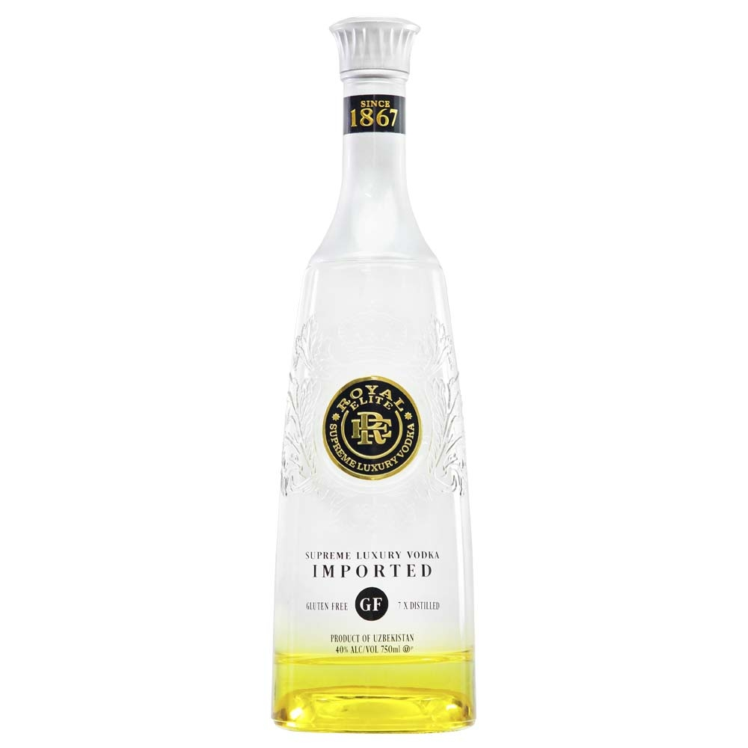 | Vodka "Royal Elite Gluten Free"  Soft as silk and produced from the best golden wheat, using the legendary worldwide healing water of Uzbekistan, Royal Elite originates from the courtyard of the Emperor Tamerlane and is produced by the revered Tashkentvino Combine, known throughout Russia and Central Asia as a leading manufacturer of soft vodkas , cognacs and wines.  Vodka Royal Elite Gluten Free provides the highest quality vodka for those who enjoy a gluten-free diet. This vodka has an added advantage, as it is perfect for Easter. No, you are not mistaken: it's real, traditional vodka, without the use of flavors.
 | 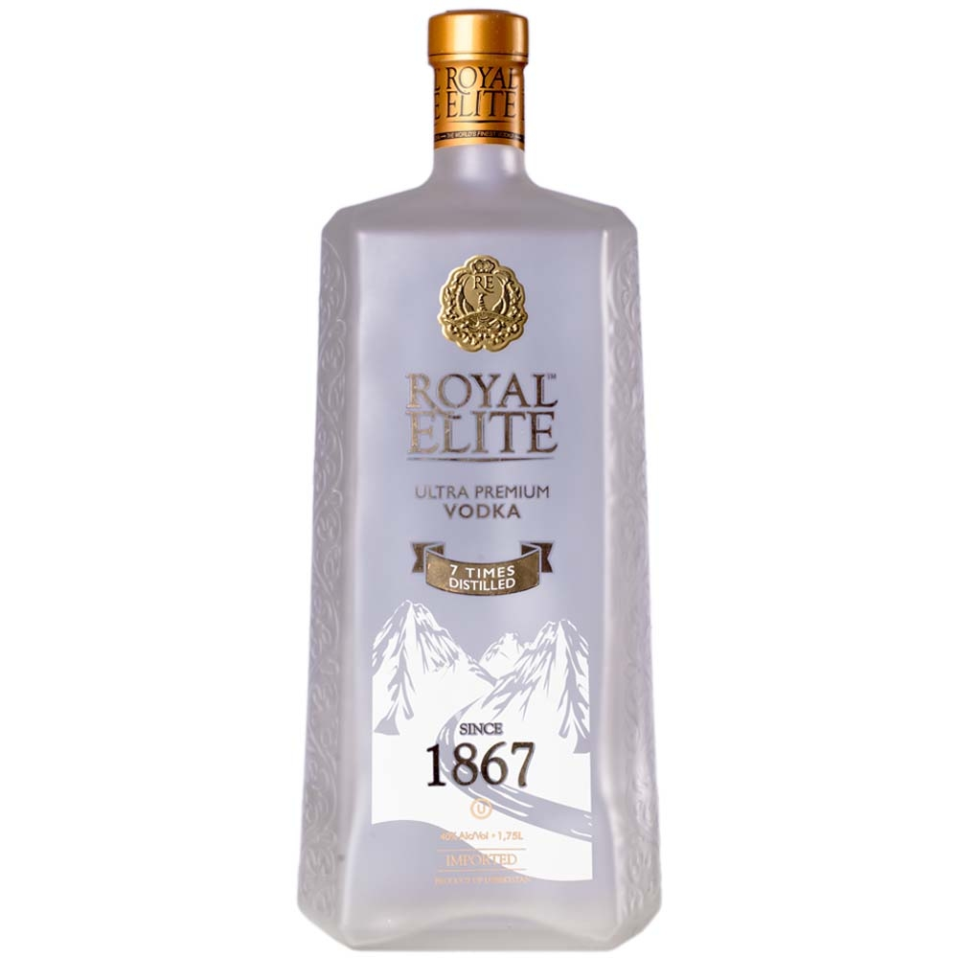 | Vodka "Royal Elite Ultra Premium Vodka"  Soft as silk, produced from the best golden wheat, using the legendary water of Uzbekistan Royal Elite Gold Label - "Ultra Premium Vodka" passed seven stages of cleaning with modern equipment installed at the Tashkentvino Combine.
 | 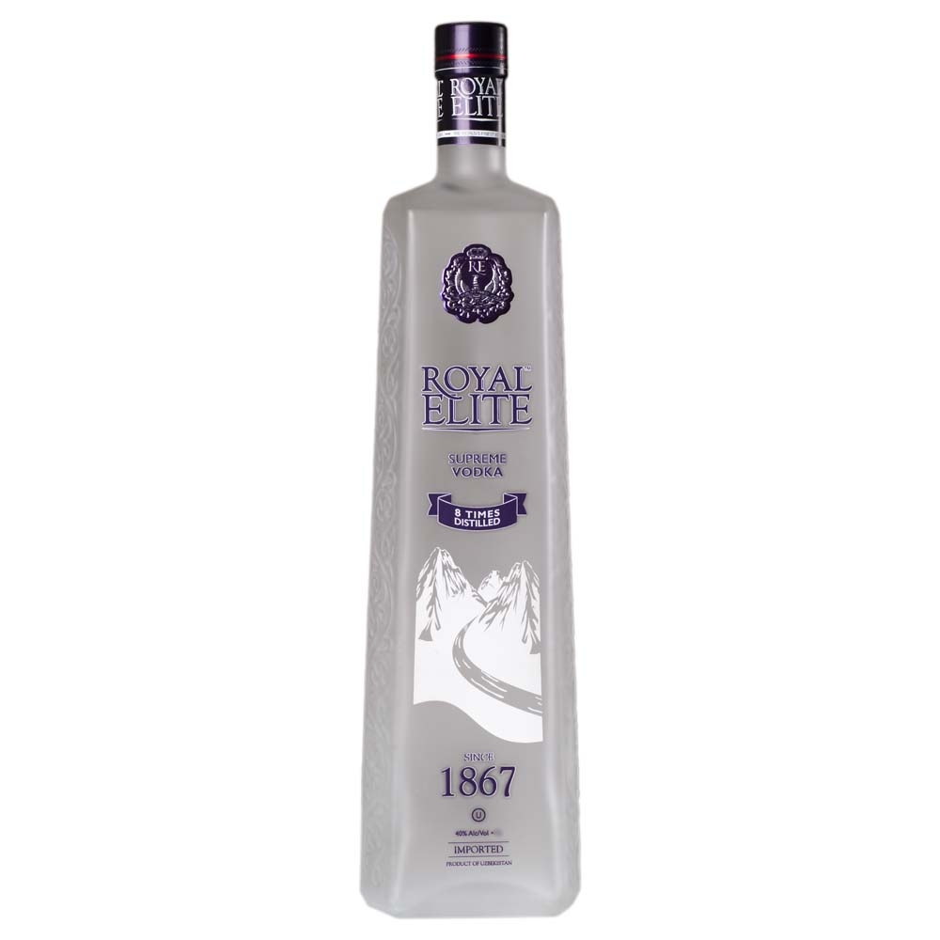 | Voska "Royal Elite Supreme Vodka"  Royal Elite Purple Label "Supreme Vodka" is considered one of the best quality vodkas available on the market today. Royal Elite Purple Label "Supreme Vodka" passed eight stages of cleaning with modern equipment installed at the Tashkentvino Combine.
 | 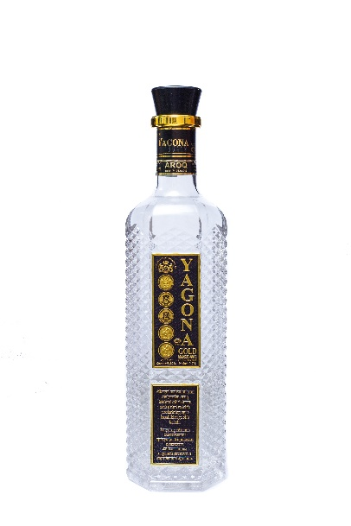 | Vodka «Yagona»  Improved vodka, clear, clean, colorless, the bouquet is of a type, without foreign taste and aroma
 | 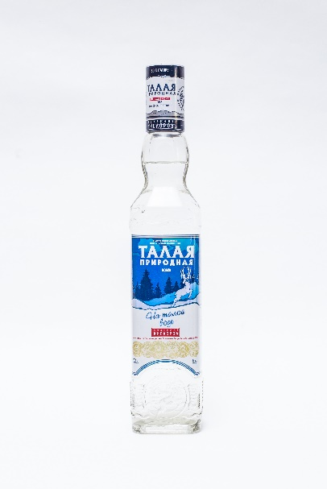 | Vodka «Talaya»  Improved vodka, clear, clean, colorless, the bouquet is of a type, without foreign taste and aroma
 | 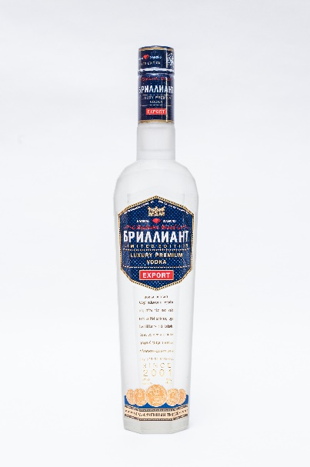 | Vodka «Brilliant»  Improved vodka, clear, clean, colorless, the bouquet is of a type, without foreign taste and aroma

